

Exhibit 1.2
Governance Framework

VA-180915-IBTL: End User Services-Computing

COMMONWEALTH OF VIRGINIA
VIRGINIA INFORMATION TECHNOLOGIES AGENCY (VITA)
SUPPLY CHAIN MANAGEMENT DIVISION
11751 MEADOWVILLE LANE
CHESTER, VIRGINIA 23836

Table of Contents
1.0 Introduction 3
1.1 Purpose and Guiding Principles 3
2.0 Governance Policy and Approach 4
2.1 Governance Framework Overview 4
2.2 Governance Framework 5
2.3 Governance Forums 5
3.0 Relational Governance Forums 9
3.1 Platform Relationship Meetings 9
3.2 Relationship Management Committee 10
3.3 Executive Alignment Meeting 11
3.4 Platform Relationship Review 12
4.0 Operational Governance Forums 12
4.1 Service Tower Meetings 13
4.2 Cross Functional Operations Meetings 14
4.3 Customer Operations Meetings 15
5.0 Decision Making 16
5.1 Escalation Process 17
5.2 Strategic Decision Process 17
5.3 Documentation 18
5.3.1 Reports 18
5.3.2 Decision Documentation 18

Introduction

Purpose and Guiding Principles
Through the Information Technology Infrastructure Services Program (ITISP), the Commonwealth is building an Integrated Services Platform to achieve the following objectives:
- Maintain and improve service quality: Develop the capability to address evolving agency needs and create opportunities to improve service performance without impacting service reliability, security, and quality.
- Ensure cost competitiveness – both now and in the future: Structure service offerings so they can be more easily compared to market services at market rates. Continuously test the market, and enable the easy addition and deletion of services to the service catalog to create competition amongst suppliers and buying power for at-will agencies.
- Create a platform view of service delivery that is highly visible and accountable: Provide for Enterprise and Agency visibility of consumption, cost, performance, and supplier responsiveness. Establish a governance structure that promotes stakeholder engagement and improves the balance of Customer and enterprise needs.
The purpose of the ITISP governance framework is to protect, enhance, and grow the Integrated Services Platform (Platform). The governance framework will manage the contractual requirements and performance of suppliers, maintain relationships with Customers, and monitor the ability of VITA and the suppliers to meet the objectives outlined above. This framework will provide forums for participants to understand each other’s objectives, to ensure commitments are being met, and to implement changes as needed by the parties.
Guiding principles used to formulate the governance framework include:
- Strong and effective Customer engagement
- Resolving issues at lowest possible level
- Establishing representative groups to resolve issues
- Regularly validating and updating Operational Documents
- Monitoring contractual requirements
- Managing interparty relationships among all Integrated Suppliers
- Evolving service options and supporting innovation
- Formalizing roles and responsibilities for strategy and issue management among VITA, Customers, and Integrated Suppliers
- Aligning management of IT-related risk with overall risk management

VITA anticipates that all Integrated Suppliers will collaborate with VITA to establish and improve governance processes, particularly at the operational layer. This model will continue to evolve as the Parties identify opportunities to enhance and grow the Platform.

Governance Policy and Approach
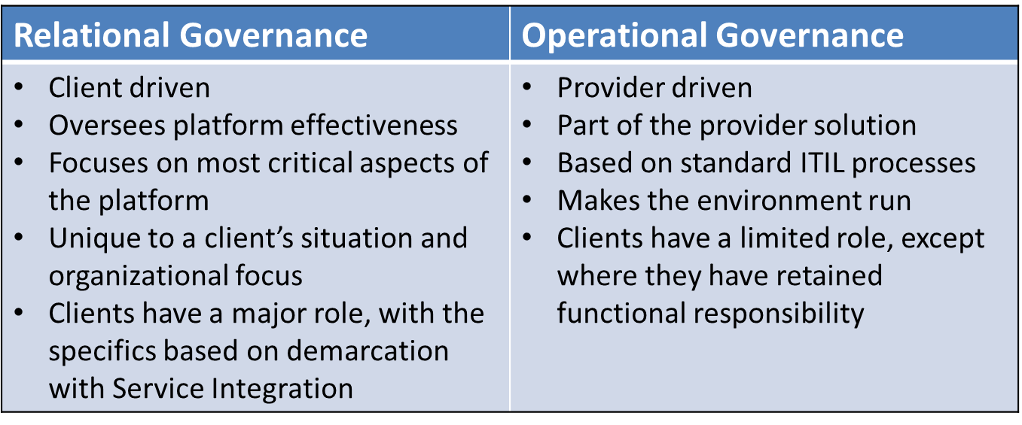
Governance must include more than meetings and escalations, and stakeholders must understand the role they play within a governance framework. The Commonwealth has applied a framework consisting of Relational and Operational governance to help stakeholders understand their role within the Platform (Figure 1).
Figure 1: Traits of Relational vs. Operational Governance

Simply put, Relational Forums will be led by VITA; they will provide strategic oversight and seek to resolve escalated issues. The Operational Forums noted below, and other such forums as needed, will be established and led by the Multisourcing Service Integrator (MSI) and overseen by VITA; they will be grounded in ITIL processes and align with the MSI’s core functions.

Governance Framework Overview
To ensure accountability and to preserve the decision rights of the Chief Information Officer of the Commonwealth (CIO), VITA sits at the center of the governance model. VITA’s Platform Relationship Office (PRO) establishes and leads the Relational Governance forums, and participates with the MSI in the Operational Governance forums. Because decision rights are retained by VITA, the PRO serves as the primary focal point for issue escalation and resolution. Relational Governance focuses on strategic issues, including the relationships among stakeholders, the ability of the Platform to meet changing customer needs, risk management, and support from the enterprise for changes to the Platform.
Operational governance will be provided by the MSI and the Service Tower Suppliers as part of service delivery. Operational components will be defined by the Customers together with suppliers, and are aligned with the processes as defined in the Service Management Manual (SMM). This includes processes such as issue resolution, service level management, change management, risk management, and reporting. The Commonwealth expects the MSI to manage operational governance forums, coordinate across forums, and drive the decisions made in those forums.
Figure 2 provides a framework for the future state service governance model. The application of this framework to the Commonwealth’s future state is discussed in the next section.

Governance Framework
The ITISP governance framework is depicted in Figure 3. This framework has been approved by the Commonwealth CIO with concurrence from the Customer Advisory Council, a governance body established by VITA to provide input on the Commonwealth’s sourcing strategy and objectives. It is designed to balance VITA’s need to manage the daily outcomes of the Managed Environment, with the Customers’ need to understand the effectiveness of the Platform and provide input into its future development.

Governance Forums
Each forum has a purpose and scope that is defined in this Exhibit. A brief definition of each type of forum is presented below.
- Committee: Group of individuals assembled to perform a defined service or function, investigate, report on, or act upon a particular matter
- Meeting: Gathering of people for a particular purpose and empowered to address and solve issues
- Review: Regular activity for a particular purpose, designated to recommend options to address a particular matter
As depicted in Tables 1 and 2 below, each forum fits into one of two levels: relational or operational. Each level is distinguished by the level of focus: overall strategy, or platform-centric engagement and accountability. The operational level reflects the initial Operational Governance Forums.
Although each forum has its own unique purpose and scope, there are interrelationships among them, including information sharing and escalation. In general, information sharing and escalation begins at the operational level, then to the management level and finally to the strategic level. The specific information sharing and escalation relationships will be defined in a more detailed governance processes in the SMM.
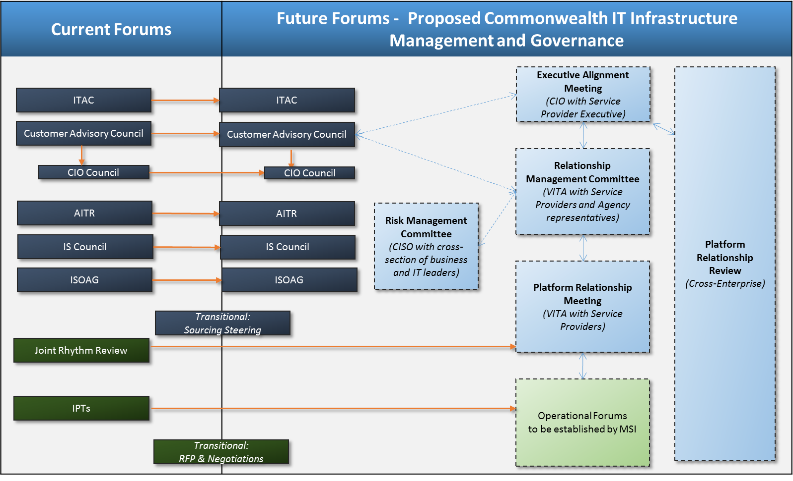
Figure 3: Commonwealth's Current and future Governance Framework

Figure 2: Framework for Future State Service Governance Model
Figure 2: Framework for future state service governance model
Table 1:
Relational Governance Forums
Meeting | Purpose | Participants | Frequency
Executive Alignment Meeting | Strategic oversight and alignment of the VITA program to the VITA and Customer business needs.  Chaired by CIO, meets quarterly or as needed; supplier executives are primary participants.  Customers attend as invited. | - CIO  - Supplier Executives | Quarterly, or as needed
Platform Relationship Review | Assessment performed by an independent advisor designed to:  - Create transparency for Customer engagement, service delivery and competing interests  - Independent enterprise review of ITISP Governance framework  - Protect the platform by validating service delivery, governance effectiveness and Customer engagement  - Identify systemic issues often missed by “normal governance”  - Identify strategic-level and portfolio-level risk to IT achieving its objectives  Assessment is delivered to the CIO | - CIO  - Independent Advisor | Biennially
Relationship Management Committee | Meeting chaired by VITA PRO Director with participation defined by the Customer Advisory Council to:  - Promote broad and effective Customer and Supplier engagement  - Ensure quality of service and cross functional integration  - Foster Customer and Supplier accountability  - Identify new services to address enterprise and Customer needs  - Manage and resolve escalated issues  - Provide oversight of organizational change management and transition activities  Meeting topics include:  - Escalated issue resolution  - Identification of new services  - Communication with Customer groups | - VITA PRO representatives  - Agency representatives as nominated by CAC  - MSI and Service Tower Suppliers | Monthly
Risk Management Committee | Meeting Chaired by the Chief Information Security Officer (CISO) of the Commonwealth and comprised of a cross section of business and IT leaders to:  - Promote enterprise risk management comprised of business and IT risks  - Maintain risk register including mitigation and compensating controls,  - Review and approve risk level and impact of identified changes  - Review risk mitigation progress and estimated resources  - Review Key Risk Indicators  - Foster integrated risk management at the agency level  - Opportunity to communicate back to agencies on risks that affect them  - Evaluate new technology risks  - Report risks and impacts to governance committees  - Raise issues to the CIO as needed | - CISO  - Commonwealth business and IT leaders as identify by CISO  - Suppliers as required | Monthly
Platform Relationship Meeting | Meeting chaired by the VITA PRO Director to:  Platform Relationship Forum includes the enterprise review of the Platform in the following areas:  - MSI and Tower Service Provider Performance Management, Review and Resolve Service Level Management Issues  - Relationship Management (VITA and all Suppliers)  - Resolve escalated issues (operational, financial, etc.)  - Review and mitigate risks that would impact agencies technology roadmap  - Prioritize proposals and review updates from major/transformational projects  - Prioritize proposals and review updates from SPLM (new services and service changes)  - Review top priorities from Supplier Relationship Management  - Prioritize and charter services improvements that could enhance agency operations - CSI Register  Participants are VITA staff, suppliers and (by invitation and as necessary) Customers | - PRO Director  - VITA representatives as required  - Supplier representatives | Monthly

Table 2:
Operational Governance Forums
Meeting | Purpose | Participants | Frequency
Operational Forums | Meetings chaired by VITA PRO. Designed in consultation with the MSI and based on ITIL processes, operational metrics and VITA reporting requirements.  Operational Forums will serve as the key meetings for service delivery oversight and issue resolution. If issues cannot be resolved at this level in the timeframes established in the SMM then they will be escalated to the Platform Relationship Meeting. | - MSI  - VITA PRO representatives  - Service Tower Suppliers as needed  - Customer representatives as needed | Weekly

Relational Governance Forums

Platform Relationship Meetings
Platform Relationship Meetings are chaired by VITA and are a component of VITA’s standard operating cadence. Participants in this meeting are responsible for reviewing the platform operations and customers experience for the VITA services program for all Customers. They are the first point of escalation for issues that cannot be resolved in the operational forums and will include participation of all Suppliers in the integrated platform. In addition to the topics outlined in Table 2 above, Platform Relationship Meetings topics will address:
- Issue escalation and resolutions
- Risks and Risk Management
- Contract and Finance
- Integration of new suppliers and services into the platform
- Reporting across SLAs and operational metrics
- OLA status
- Technology Roadmap
- SLAs and Service performance
- Customer experience
- Services consumption
- Opportunities / potential new projects
- Working relationship among Customers, VITA, the MSI and the Service Tower Suppliers
On a monthly basis, a month in review will be conducted and shared with the Relationship Management Committee. The VITA PRO Director in consultation with the MSI, Service Tower Suppliers and Customers will identify issues and escalations for the Relationship Management Committee. Agendas for the Relationship Management Committee will be distributed to Committee participants at least 3 days prior to any schedule meeting.

Relationship Management Committee
While Customers are engaged at each level of the Commonwealth’s governance framework, the Relationship Management Committee (RMC) is the cornerstone of Customer involvement. Customer participation in this Committee has been defined by VITA’s Customer Advisory Council based on groupings of Customers sharing common business functions. The RMC is a leadership body providing general management and oversight to ensure the VITA program services, processes and practices are meeting Customer IT and business requirements. It will conduct a monthly Customer-oriented review of the performance of the Services, customer experience and related governance program activities across the ITISP. In addition, plans and status of active Integrated Services Platform initiatives and on-going programs will be reviewed.
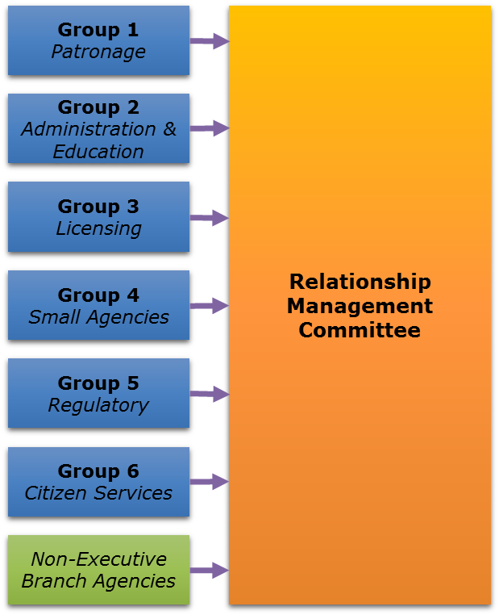
The RMC’s scope is: Responsibility for the oversight and general management of Integrated Services Platform. The Committee reflects (6) groups of (10) executive branch agency Customers grouped by common business functions. The Customer Advisory Council aligned the names of the groups and the common business functions with the COV Enterprise Business Architecture Line of Business Report. The six groups will facilitate a small group environment, and encourage collaboration and candid feedback on service delivery concerns. Each agency selects their advocate for their agency to participate in the group. Each group will also select one representative to represent their group of agencies on the RMC. The composition of the RMC is depicted in Figure 4.
Figure 4: Customer representatives on the Relationship Management Committee
The RMC’s responsibilities include:
- Promote broad and effective agency and service provider engagement
- Foster agency and service provider accountability
- Manage and resolve escalated issues
- Provide oversight of organizational change management and transition activities
- Ensure quality of service and cross functional integration
- Review the Integrated Services Platform’s performance from Customer perspective, including:
  - Service performance
  - Financial management
  - Risk management
  - Services consumption
  - Customer experience
  - Projects
- Review Integrated Services Platform initiatives
- Identify new services to address enterprise and agency needs
The topics to be addressed by the Relationship Management Committee include:
- Service performance
- Customer satisfaction and experience
- Financial and services consumption summaries
- Project performance
- Issues, risks, and resolutions
- VITA program initiatives
- Identification of new services
- Communication with agency groups
VITA will chair the Committee, and the MSI and all Service Tower Suppliers will be required to attend. The RMC will meet monthly.

Executive Alignment Meeting
The Executive Alignment Meeting is the forum through which the CIO will conduct formal engagements with integrated Supplier executives on issues important to the overall health of the Platform. This Meeting, to be held separately with each supplier, will provide business oversight, ensure that the Commonwealth’s Service delivery objectives are achieved and serve as the final point of escalation for issues unresolved at lower levels. Ultimately the CIO has responsibility for oversight of the strategic direction of the ITISP.
The Executive Alignment Meeting supports:
- Strategic business alignment between the CIO and supplier executives
- Strategic relationship and executive contractual agreements with service providers
- Oversight and formal CIO escalation with service providers
- Optimal use of the VITA program and its alignment to broader strategic initiatives.
- Alignment of the strategic direction of the VITA Program to the VITA customer’s business outcomes
- Fostering of strategic partnerships that are aligned to the contractual agreements and meet customer experience expectations
- Strategic decisions for the VITA Program
- Strategic risk management for VITA program
- The topics to be addressed by the Executive Alignment Meeting include:
- Business alignment among VITA, Customer and Supplier business plans, and oversight of new or modified Services during the Term
- Strategic requirements and plans associated with the Services or New Services during the Term
- VITA program overview
- Quality; Service Level performance
- Innovation, continuous improvement and quality assurance measures
- Reset of Critical Service Levels
- Financial performance
- Customer Experience including customer satisfaction surveys
- Audit results
- Escalated unresolved issues
- Changes to the Agreement
- Quarterly review and outlook
- Overall health of the various Service Tower Supplier and VITA relationships

While the Executive Alignment Meeting is a critical element of the Commonwealth’s governance framework, it is not intended to serve as the only forum in which the Commonwealth CIO engages with Supplier executives. It is expected that the Commonwealth CIO will have clear lines of escalation within Supplier organizations and will establish and maintain relationships with Supplier executives with responsibility for their respective accounts and lines of business.

Platform Relationship Review
The Platform Relationship Review will have responsibility for protecting and enhancing the Platform by encouraging transparency and regular review of systemic or recurring issues.
The overall purpose of the Platform Relationship Review is defined as:
- Create transparency for Customer engagement, service delivery and competing interests
- Independent enterprise review of ITISP Governance as documented in the Service Management Manual and implemented
- Protect the Platform by validating service delivery, governance effectiveness and Customer engagement
- Identify systemic issues often missed by "normal governance"
- Risk management of platform
The Platform Relationship Review will be conducted biennially (i.e., every other year) by an independent advisor or consultant, delivered to the Commonwealth CIO.

Operational Governance Forums
Operational governance consists of day-to-day management of the Services, issue resolution, and Customer-specific technology decisions. Success of the governance model rests largely on managing operational governance, including resolving issues and making decisions, at the lowest possible level. Thus, the vast majority of issues are resolved through interaction among VITA, the MSI, and the Service Tower Suppliers; Customers are included as appropriate. This approach provides for good management practice, with individuals who have the greatest knowledge of the situation empowered to act, and enables the governance committees to focus on escalated issues and strategic decision making. Customer inclusion will provide transparency into Platform operations, provide VITA with insight into issues that require escalation, and provide the MSI and Service Tower Suppliers with needed information about agency business operations and requirements.
To enable VITA’s role in overseeing the Agreement, VITA interfaces with Customers and Integrated Suppliers on a variety of enterprise issues. On a daily basis, VITA management and technical staff interface with VITA Customers and Integrated Suppliers to answer questions about the Agreement, understand and resolve issues, and facilitate communication and coordination. VITA will also have regular enterprise operations meetings with the MSI and appropriate Service Tower Supplier staff to manage the Agreement. The meeting topics will include the following topic areas:
- Service delivery and operations performance
- Problem Management
- Availability and Capacity Management
- Finance, invoices, and chargeback
- Contract administration and Deliverables
- On-Going Programs
- Service Portfolio Review
- Process Evaluation and Currency
- SMM and OLA Currency
- Continual Improvement
- Technical Currency and Innovation
- Knowledge Management
- Technology standards and long-range planning
- Service level and performance management
- Security and disaster recovery management
- Transition management
- Stabilization management
- Consolidation management
- Customer Satisfaction
- Customer Relationship management
- Issues Management and Governance
- Complaint Management
- Risk Management
- Asset Management and License Compliance
- Services Management Manual currency
- Solution Request management
The MSI will be responsible for managing the cadence and reporting of these forums as documented in the SMM, unless directed otherwise by VITA. Initial Operational Governance Forums are described below.

Service Tower Meetings
The Service Tower Meetings will perform a Service Tower-specific review of the performance of the Integrated Services Platform. There will be a separate meeting for each Service Tower Supplier (for the purposes of these meetings, MSI services are considered a separate “Service Tower”).
The overall scope of the Service Tower Meetings is defined as: the oversight, review, and management of service operations for each Service Tower.
The overall purpose of the Service Tower Meetings may be defined as:
- Provide general management, oversight, and review of the service delivery for each individual Service Tower (and separately, the MSI)
- Manage operational and customer experience risks and issues
- Monitor in flight projects
- Review proposed project activity
- Review resource consumption, as applicable
- Review proposed and planned technology changes
The topics to be addressed by the Service Tower Meetings include:
- Service performance
- Significant projects – in flight
- Significant projects – proposed
- Services consumption
- Issues and risks
- Proposed and planned technology changes
The Service Tower Meetings will be initially comprised as follows:
VITA
- PRO member (“service owner”)
- Other VITA personnel as required (i.e. supplier relationship management, finance, etc.)

Service Tower Supplier
- MSI Service Delivery Lead (Chair), (except for the MSI meeting, where the MSI Service Delivery Lead will attend and a PRO member will be Chair)
- Other MSI Supplier personnel as required
- Service Tower Supplier Service Delivery Lead (Co-Chair), (except for the MSI Meeting)
- Other Supplier personnel as required
Customers
- Customer representatives – optional, at VITA’s discretion
Service Tower Meetings will occur weekly or as defined in the Service Management Manual, and at other times as agreed by the VITA and the supplier.

Cross Functional Operations Meetings
The Other Defined Operational Meetings will perform a cross functional review of the performance of the Integrated Services Platform, such as project management, security, architecture. There will be a separate meeting for each cross functional topic, as defined by VITA and the MSI.
The overall scope of the cross functional reviews is defined as: the oversight, review, and management of service operation and integration for each function (bother between suppliers and VITA functional areas).
The overall purpose of the Cross Functional Meetings may be defined as:
- Provide general management, oversight, and review of the service delivery for each individual function
- Confirm compliance of VITA and Commonwealth standards
- Approve any exceptions to VITA/Commonwealth standards
The topics to be addressed by the cross functional Meetings include:
- Compliance to standards (i.e. architecture, project management, change control, etc.)
- Exception requests to standards
VITA
- PRO member (“service owner”)
- Other VITA personnel as required (i.e. architecture, program management, security, etc.)
Service Tower Supplier
- MSI Service Delivery Lead (Chair)
- Other MSI Supplier personnel as required
- Other Supplier personnel as required
Customers
- Customer representatives – optional, at VITA’s discretion
Cross Functional Meetings will occur weekly or as defined in the Service Management Manual, and at other times as agreed by the VITA and the supplier.

Customer Operations Meetings
The Customer Operations Meetings will be responsible for reviewing and collaborating on Customer business goals, in order to understand how IT supports business processes and enhances overall Customer experience. The overall scope of the Customer Operations Meetings is defined as: Responsibility to understand, monitor, and collaborate on service provision to continually improve the customer experience.
The business purpose to be addressed by Customer Operations Meetings include:
- Understand Customer business goals and objectives
- Understand how IT supports business processes
- Current Customer IT planning
- Future IT needs
- Timeliness
- Accountability
- Operational issue and risk identification and resolution
- Technical change management
- Customer one-on-one meeting
- Collaborate on Customer specific solutions
- Supplier and Customer resource review
- Risk Management
- Monitor customer experience

The topics to be addressed by Customer Operations Meetings include:
- Status of service and solution requests
- Refresh status
- Service level reviews
- Root cause analysis
- Transition status
- Review technology roadmap
- Impact of IT infrastructure on Customer projects
The Customer Operations Meetings will initially include:
VITA
- Customer Account Manager
- Other VITA personnel as required

Service Tower Suppliers
- MSI customer operations manager COM (Chair, with responsibility for Co-Chair duties)
- Service Tower Provider representative(s) as needed.
Customers
- Customer AITR, IT Resource or designee
The Customer Operations Meetings will occur weekly to monthly, with the MSI AOM. Meetings will include service tower representatives as needed.

Decision Making
Governance committees address two types of decisions:
- Issue resolution
- Strategic decisions
Issues may be Customer issues or enterprise issues identified by VITA, Customers, or Integrated Suppliers. Issues are escalated following the escalation process described below. Strategic decisions may be identified by VITA, VITA Customers, the MSI or Service Tower Suppliers.

Both decision types are treated the same by the governance forums:
- All Customers have an opportunity to see the issue
- VITA triages the issues in an attempt to resolve, and routes unresolved issues to appropriate committees
- Customers and the Tower Suppliers will each have an opportunity to document their perspective
- Customer committee members will review positions/perspectives in order to represent their partner agencies in the meeting
- All decision-making agenda items will be broadcast in advance of the meeting and will have a corresponding risk evaluation
- After the meeting, decisions will be documented with the issue

Escalation Process
As noted above, the governance model strives to resolve the vast majority of issues at the operational level. The MSI is expected to facilitate these resolution processes, in accordance with other processes in the Agreement and the SMM as applicable. Supplier personnel participating in forums are expected to be able to make decisions and resolve issues as appropriate for the level and purpose of that forum. However, not all issues will be resolved at the operational level, so the governance model includes an escalation process designed to promptly and efficiently escalate the issue for resolution. Most operational issues will be routed to the Platform Relationship Meeting; however, in some cases high profile business, technology, and financial issues will be routed to the RMC. Ultimately, the CIO of the Commonwealth retains decision-making authority. When issues cannot be resolved in one of the other forums, they may rise to the CIO.
After VITA, the Customer and Supplier determine an issue cannot be resolved at the operational level and it cannot be resolved with escalation to MSI, the issue is escalated to the Platform Relationship Meeting. VITA triages and makes a further attempt to resolve. If resolution is not reached quickly, then VITA escalates to the RMC.
VITA also coordinates with the Customer, Supplier and Service Tower Suppliers involved in the issue to complete the required documentation for Customer input on the process as follows:
- VITA assigns an issue number
- VITA develops and confirms the issue description, a statement of the facts in the situation
- VITA, Customer and Supplier develop issue resolution paper
- VITA provides details including, as applicable, cost implications, additional factual background, contract references, and previous solutions attempted
- Customer completes relevant facts, artifacts, and documentation from their perspective
- Supplier completes relevant facts, artifacts, and documentation from their perspective, coordinating with Service Tower Suppliers as needed
- VITA compiles all information into a single document
VITA coordinates the distribution of the issue material with the meeting agenda. Meeting agendas and associated material are distributed to Relationship Management Committee members in advance of the meeting, with approximately 5-7 Business Days for Customers to review and provide input to their committee representative and approximately 2 days for VITA to compile the comments received for distribution to all.

Strategic Decision Process
Strategic program decisions may be required by the Agreement (e.g. Annual Technology Plan, technology standards, changes to governance framework) and, thus, follow a prescribed timing cycle or they may arise from a technical constraint, opportunity or business need. Regardless of the source, strategic decisions follow a similar process to escalated issues:
- VITA coordinates the development of background materials to explain the decision, implications for the enterprise, and any technical considerations that are relevant. This coordination may include the engagement of Customers, Supplier or Service Tower Supplier subject matter experts to create materials and complete technical analysis.
- VITA develops a format for Customer input appropriate for the decision.
VITA coordinates the distribution of the issue material with the meeting agenda to the Platform Relationship Meeting participants for initial review. After feedback is received through the Platform Relationship Meeting, agendas and associated material are distributed to the RMC, with approximately 5-7 Business Days for Committee participants to review and provide input to their committee representative and approximately two days for VITA to compile the comments received for distribution to all.

Documentation

Reports
In the case of all meetings, minutes will be prepared by the meeting Co-Chair and will include topics discussed, issues resolved and open action items with responsible person’s name and date to close action.

Decision Documentation
After all committee meetings, VITA documents decisions made and completes any follow up tasks such as updates to associated artifacts (e.g., Agreement, Service Management Manual). Decisions are posted to the Portal for visibility by all Users as authorized by VITA.

