

Exhibit 2.3.1
Solution – End User Printing and Hardware

VA-180915-XERX: Managed Print Services

COMMONWEALTH OF VIRGINIA
VIRGINIA INFORMATION TECHNOLOGIES AGENCY (VITA)
SUPPLY CHAIN MANAGEMENT DIVISION
11751 MEADOWVILLE LANE
CHESTER, VIRGINIA 23836

Table of Contents
1 Introduction 3
2 Common Services 6
2.1 General 7
2.2 Field Services and Technical Support Services 18
2.3 Hardware Services 22
2.4 Security 28
3 Managed Print Services 42
3.1 Initial Operating Capability 48
4 Enhanced Services 53
4.1 Value Added Services 53

Introduction
The Xerox methodology employed in this solution includes four key planks to ensure a comprehensive solution at each stage of the lifecycle.
- Assume and Manage –The infrastructure that Xerox already has in place with Agencies, combined with the coverage of Xerox’s SWaM (small, women-owned, or minority-owned) sub-contractor, NTS, enables Xerox to provide a seamless take-over of the existing fleet.
  - Assume ownership and management/maintenance/lifecycle refresh of Hardware – Xerox will begin with an overall assessment and inventory of all existing devices to determine current needs, maintenance requirements, and Hardware refresh.
  - Provide all services necessary to print, image, and scan – Xerox will provide the broadest device and service portfolio in the marketplace. Combining the Xerox portfolio with the third-party offerings through Xerox’s team of partners will provide VITA with a catalog that is both broad in offering type and deep in selection.
  - Lifecycle management – As part of Xerox’s lifecycle management strategy, Xerox will follow each Customer’s guidelines and tailor Xerox’s approach to each Customer’s needs.
Xerox will conduct formal assessments and analysis that generates reports and gauges that provide an overview of the current environment, including current utilization, cost per print, environmental impact as well as other metrics.
  - Provide all print Consumable Supplies – The Xerox solution will provide all print Consumable Supplies as required for the full functionality of the device for all VITA network printers and multifunctional devices.
  - Coordinate all activities with MSI – The Xerox team will collaborate with MSI throughout the entire life of the contract. Xerox understands the importance of a close, collaborative relationship to enable the MSI to oversee and manage a seamless delivery of service. Xerox will meet regularly with MSI and provide the support needed throughout the contract. Xerox’s dedicated VITA team will be available to the MSI through multiple communication channels and will provide contact information at contract start.
  - Provide management tools and reporting through MSI – Xerox’s benchmark tool suite is a web-based asset tracking and management application that will enable Xerox to manage all VITA networked print Devices and all service-related incidents. Xerox will provide the MSI access to Xerox’s tool suite to provide an overall view of Xerox’s portion of the entire program, and monthly reporting will be presented to MSI and VITA. The Xerox tool suite is comprised of the following key applications:
- Xerox Device Manager (XDM)—the critical onsite component of Xerox’s technology infrastructure. Its primary functions include: discovering network connected printers and multifunction devices, monitoring the networked output devices for status, alerts and meter read data, automatically communicating encrypted Device information and status data to Xerox Services Manager (XSM) at an ISO27001 certified Xerox data center, and obtaining direct connect and peer-to-peer printer usage transactions using client-side job tracking software.
- Xerox Services Manager (XSM)—provides an asset management system that will track asset-specific information such as location, contacts, service level agreement, and costs. XSM delivers rich remote Device management functionality that allows the Xerox Help Desk to perform Device management functions that previously required someone to be onsite, import and export data to and from the Xerox assessment tools to support due diligence and optimization components of the Xerox services, and aggregate and report on customer due diligence and financial data collected during the due diligence process to provide total cost of ownership reporting as well as a baseline for operational activities. XSM will be integrated with MSI’s SMS allowing access to reporting, data, and analytics.
- Xerox Report Manager (XRM)—interfaces with Xerox Services Manager (XSM) to collect, consolidate, and report on asset and service related activity. Also, XRM will generate reports on an on-demand basis or through pre-defined schedules with both detailed and summary capability, allow for output data formatted as tables, pivot tables, and charts, in MS Excel and MS PowerPoint as well as in PDF, XML, CSV and MS Word formats. There are over 55 standard reports available as well as the capability to create ad hoc and custom reports.
Additionally, Xerox Print Management and Mobility Suite (XPMMS) is available to purchase through this contract and will enable authentication, authorization, and accounting as well as secure printing and user-level reporting.
- Desktop printer support as an option – Customers may opt to purchase, subject to VITA approval, comprehensive services, supplies, and management of desktop printers based on a flat rate per printer, to be agreed upon at the time of purchase, and utilizing the Xerox statewide service infrastructure already in place.
- Reactive Usage Monitoring: Xerox will obtain meter reads for non-reachable devices utilizing one of the following methods:
    - Xerox Help Desk agent will contact Device point of contact to obtain meter reads
    - Xerox Technical Service Representative will retrieve during service call
    - Xerox Service Delivery Coordinator will obtain meter read from the Device
- Assess and Measure – Xerox’s thorough assessment process beginning upon Effective Date will enable each Agency to realize efficiencies, cost savings, and optimize current Device usage. Below is a sample of Xerox’s capability to reduce costs and increase efficiencies based on a 375-Device environment.

Table 1. Enterprise Impact. Cost and Efficiency 375-Device environment sample
Metric | Current State | Future State  Option 1 | Future State  Option 2
Employee to Device Ratio | 2.5:1 | 8:1 | 5.1
Total # of Devices | 375 | 123 | 191
Total Monthly Cost | $42,136 | $28,162 | $31,352
Total Monthly Savings |  | $13,974 | $10,784
Total Annual Cost | $505,632 | $337,944 | $376,224
Total Annual Savings |  | $167,688 | $129,408
Percentage Savings |  | 33.16% | 25.59%

  - Managed Print Services review and documentation – The Xerox team will provide a thorough review and documentation through monthly and quarterly business reviews with MSI and VITA. These business reviews will share insights on opportunities for improvement based on analytics collected, review performance scorecard and metrics from data gathered, review volumes, observations & trends and share ideas for innovation to address the ever-changing client environment.
  - Analyze and address - Xerox will analyze the current environment to ensure that technologies and systems that comprise the MPS environment comply with all VITA Rules. Any technologies or systems that do not currently meet VITA Rules will be flagged immediately following detection and remediated to ensure compliance with VITA Rules.
- Automate and Simplify – The Xerox team will identify, and propose to VITA for acceptance, business improvement opportunities to streamline processes and achieve additional productivity and cost savings
  - Realizing efficiencies and identifying improvement. While reviewing the current environment, Xerox will make recommendations for performance improvement and efficiencies where possible. Recommendations are based on current experience and industry data and include optimizing the number of Devices, ways to increase Device utilization and identifying and streamlining paper intensive and highly manual processes.
- Improve and Control – Xerox will evolve the current environment, improve performance, increase efficiencies, and enable transitions to next-generation solutions as needed.
  - Alignment with new technologies. Xerox owns three research centers that are dedicated to finding innovations in enabling sustainable enterprise, printed electronics, and creating agile business processes. Xerox’s two-pronged innovation approach includes customer-led innovation and open innovation. Xerox partners with both customers and organizations worldwide to enable products and solutions that respond to the needs of the emerging and global markets. Xerox’s Solutions Architect will host annual or bi-annual knowledge sharing sessions with VITA and the MSI to ensure that both organizations are kept aware of new technologies.
The Xerox Solution provides a comprehensive environment, with all support, repair, and Consumable Supplies included. The success of the Xerox Solution is rooted in the following elements:
- Dedicated Team - Xerox will assign a dedicated support team of experienced professionals consisting of eight essential onsite personnel to oversee and manage the success of the Xerox MPS Solution within VITA and in partnership with the MSI. Xerox’s key personnel team is supported by statewide service coverage and Xerox’s full corporate reach. The inclusion of eight essential onsite personnel is driven by integration sessions conducted with MSI and VITA as well as the integration session with MSS Provider and VITA.
- Assumption of Assets –Xerox will assume immediate support of the existing multifunction devices, network and local printers, scanners and plotters and provide a comprehensive MPS environment that includes break-fix and consumables immediately without any disruption in service.
- Catalog Breadth - Xerox will provide a broad, multi-branded offering catalog consisting of monochrome and color, desktop and workgroup, single function and multifunction printers in addition to a variety of scanners and plotters. OEMs include Xerox, Hewlett Packard (HP), Lexmark, Fujitsu and Canon/Océ.
- Service Excellence – The Xerox team will deliver to VITA unparalleled service, seamless management, and future-forward services and management. Pairing 24x7x365 Help Desk support with Xerox’s expert technicians, highly-skilled and dedicated staff, and Xerox’s Tool Suite will provide proactive monitoring, dispatch, and reporting. The in-depth reporting will target areas for continual improvement, and action plans for such areas will be created and executed by Xerox.
- Processes & Enablers – Beginning with Xerox’s ITIL framework and Lean Six Sigma processes, Xerox will tailor Xerox’s approach to the VITA and MSI framework, processes, policies, and procedures to ensure an overall seamless program can be effectively managed to enhance services and minimize risk upon identification of the need for improvement.

Common Services
Xerox’s Common Services include:
- Cross-Functional Requirements - Xerox will collaborate with MSI, VITA, and stakeholders to effectively meet program goals, requirements, and provide a seamless, low-risk Solution.
- Multi-tier support level environment – Xerox will provide a multi-tier support environment. All network-connected Devices will be monitored proactively using XDM. This allows for in-scope Devices to communicate directly with Xerox to reduce the involvement necessary from VITA, MSI, or the end-user when a trouble call needs to be reported. The Xerox Help Desk will provide VITA with a locally operated customer care resource to receive requests for services related to break-fix, supplies, relocations, or inquiries. If the Xerox Help Desk is unable to resolve an issue over the phone, a technician will be dispatched. The Xerox Help Desk will provide trouble ticket management and track all open tickets through to resolution and closure. To support the on-site technicians, Xerox will employ an integrated-service call escalation process that utilizes local field specialists along with 2nd-level technical support and development engineers for in-process service calls. For designated priority end users, Xerox will also provide VIP support.
- End-user services – Led by Xerox’s team of key personnel, Xerox will provide a tiered support structure. Standard support will include onsite service technicians as well as 24x7x365 remote support. Using XDM, Xerox’s technicians will arrive prepared to repair the Device using data collected from XDM Device remote alerts. VIP Devices will benefit from an additional level of access to onsite operational support for needs that require immediate and/or desk side assistance.
- VIP Print Device support – Xerox will provide VIP Print Device support for VITA. VITA will provide Xerox a list of Devices that will be serviced as a VIP location upon Commencement Date. These Devices will have enhanced service levels to meet VITA’s defined business needs.
- Service to meet VITA’s needs – Managed by Xerox’s dedicated Account Executive and Account Manager, Xerox has a team who will meet the daily service needs of VITA. In addition, Xerox currently has 99 technicians supporting customers in the Commonwealth of Virginia. Should a problem need to be escalated Xerox will give a specific escalation plan to allow for service resolution.
- Secure and Confidential services – Xerox’s dedicated Security Manager will oversee the safe implementation of Hardware/Software in compliance with VITA Rules and the SMM. Xerox will configure Device settings according to VITA Security standards baseline and provide ongoing reporting to show compliance. Any compliance gaps will be highlighted and corrected by Xerox. Xerox will act in a way to safeguard information and should a non-disclosure be required Xerox will comply.
- Continual Service Improvement – As part of Xerox’s dedication to continuous service improvement, Xerox will continually assess the environment through reporting and analyses to recommend areas for improvement. Xerox’s team of experts will continually look for ways to improve workflow, processes, and procedures. Areas of focus include Hardware, Software versions, and all solutions to ensure the most current solution elements and practices are in place. Additionally, Xerox conducts self-assessments during the business review preparation process which highlights opportunities for improvement based on analytics collected. This acts as a performance scorecard and in conjunction with feedback from VITA and MSI will be used to continually improve and evolve service delivery.

General
Effective End-to-End Management
Xerox will provide effective end-to-end management, monitoring, and reporting in accordance with the SMM and VITA Rules, through the Xerox tool suite. Xerox’s SMS, Xerox Services Manager, will be integrated with the MSI SMS for real-time updates and status of Service Request. When the Customer contacts the MSI help desk, the MSI may escalate the Service Request to the Xerox Help Desk as needed. The Xerox team will provide status updates as required throughout the life of the Incident.
In addition to reactive notifications from Customers, Xerox’s solution includes proactive Device management to VITA. Xerox Device Manager (XDM) will receive an alert from the Device and generate an incident in XSM. Due to the integration with the MSI SMS, the ticket will also be created in the MSI system. XDM also collects and manages asset data to drive fact-based decisions for Device management environments. XDM will communicate with all brands of Devices that are connected to VITA’s network and enables the Xerox team to improve the efficiency of the document output environment to reduce costs. XDM performs Device discovery, configuration and management, job tracking and visualization, proactive monitoring, remote diagnostics, and troubleshooting as well as automated and ad hoc reporting. Below is a visualization of how XDM communicates as well as of the XDM dashboard.
Please see the following attached documents for data on Security protocols and ports regarding XDM.
- REDACTED.
Communication with Users (Training & Knowledgebase)
The dedicated support team, the Xerox Help Desk and the service engineers supporting VITA are fluent in English and are well versed in providing clear verbal and written communications. Xerox will develop and build user training in accordance with SMM and will begin with the following essential user training topics: how to use the functions of the Device, jam clearance, adding toner, how to self-register badges and use badging features. Xerox will provide communication on how to request Support as well as utilize instructional videos and a guidance tool that populates specific directions based on subject matter required through Xerox’s online Support link.
Xerox will monitor Xerox’s Help Desk user support calls to develop a frequently asked questions list, provide recommendations on knowledge-based entries, and create additional recommendations for areas of training, all in accordance with SMM and VITA Rules. Xerox will make all training available to users 24x7x365 on VITA’s knowledge assets.
Xerox’s professional instructors will tailor end-user training programs for each environment with a core focus on the following:
- New Processes - How processes can be changed, updated or replaced with more effective methods to ensure VITA is achieving maximum productivity with each Xerox solution.
- VITA’s Environment - Working within VITA’s current technical and workflow environment, how VITA can realize maximum value from VITA’s Xerox solutions.
- Device Uptime - Learning how to achieve optimal equipment uptime with VITA’s Xerox solutions.
Additionally, Xerox will tailor end-user training according to the users’ preferred learning methods and the components of the solution design. Training processes will be coordinated with the MSI and VITA and Xerox will deliver training on-site via a professional instructor, through an instructor-led webinar or on demand via pre-recorded training posted online.
On-site customer training is recommended and will be provided by Xerox to users with less experience with Xerox technology and for those who would benefit from a hands-on session in front of the new Device.
Webinar training is offered for users who enjoy technology-based instruction but also prefer training to be instructor-led. This virtual classroom training will allow participants to remain at their desks and participate with up to 20 other learners in a classroom-style training session. End users will have the ability to ask questions and interact live with the instructor.
On-line training is available for users who prefer the flexibility of participating in training when and where it is convenient for the user. Internet training sessions are available 24x7x365 through xerox.com. Training sessions are arranged into modules that will allow for easy access to refresher training on specific product features and functionality.
After training has been completed, follow up visits will be conducted by the Service Delivery Coordinator to ensure that users have a comfort level using the Device and that post-training questions that have been answered.
The topics below are the underlying fundamentals of each training. Additional topics like badge print release will be incorporated based on the solution implemented. Xerox will comply with VITA planned training program requirements and request VITA review and approval prior to the training roll out.
Table 2. Fundamental Training Topics
Training Topic | Fundamental Training Items Reviewed
Introduction | - Review the content of the training session to ensure requirements are met
Product Overview of the Main Components | - Tray / media specifications  - Finishing unit  - Document Feeder  - Control panel / user interface
How to Copy a Job | - User screens such as Features, Job Status, and Machine Status  - Touchscreen tabs including setting paper tray attributes, using the Auto features, image adjustment features (reduce/enlarge, shift, and erase), job layout features (covers, booklets, mixed media), productivity features (storing, building jobs), and color adjustments (if applicable)
Overview On How to Print a Job by Selecting Job Parameters | - Paper / output selections  - Image Adjustments  - Layout such as multiple-up, booklets, and watermarks  - Printing workflows through the driver (special pages)  - Secure Print / Delayed Print / Sample set
How to Fax a Job  (If Applicable) | - Accessing Fax  - Sending basic fax  - Storing fax numbers  - Speed dial  - Fax confirmation  - Additional Fax features available
How to Scan a Job | - Accessing network scanning  - Selecting Scan to Desktop template or scan to mailbox  - Additional scan features selections available prior to sending
How to Use Scan to Email | - Accessing email  - Addressing recipients  - Storing addresses locally  - Choosing file type and other settings available prior to sending
Load Paper and Media | - Setting paper tray attributes
Maintenance and Troubleshooting | - Touchscreen instructions  - Changing Customer Replaceable Units or Smart Kits  - Replacing toner and staples  - Overview of User Guide and www.xerox.com tools available for instructions, video tutorials, and documentation
Administrator Functions (Key Operator only) | - Entering the Access Mode  - Changing machine defaults  - Setting up restricted password access (Auditron)  - Color calibration (if applicable)

System Testing
The MPS lab environment will provide for testing of new Patches, releases, service packs, applications, troubleshooting an error, or assisting with testing of new configurations by all support teams. A key area to be tested is an upgrade of firmware. Xerox maintains an RSS feed to notify subscribed parties of vulnerabilities and security Patch availability. The dedicated Xerox Security Manager will be the process owner for Patch management and will be subscribed to this feed to ensure they are notified of any potential impacts to the VITA environment. VITA or MSI personnel that would like to receive the notifications are welcome to subscribe to this feed. In addition, documentation pertaining to the tested items will be made available to VITA and will include test, audit and Security logs.
For testing purposes (firmware upgrades, integration, regression, problem replication) the Xerox team will provide one of each Xerox model platform and networked printer platform to be housed in the Xerox provide testing and certification lab. When products require substitution, the Xerox team will replace the testing Device with the newer platform. Xerox will comply with piloting and testing of new MPS Devices on VITA’s network.
2.1.1 Installations, Moves, Adds and Changes (IMACs)
Xerox will provide seamless and low-risk IMAC services to all VITA sites. The Xerox Help Desk will coordinate with the logistics carrier and Customer in conjunction with the Xerox onsite team to manage all IMAC’s per the SMM and VITA Rules.
Xerox will actively manage the process related to IMACs to ensure that all information is tracked and updated within the Xerox Integration Service (XIS) Portal and reported to the MSI. This approach will both integrate with and add value to VITA existing IMAC and disposal procedures.
Using Xerox’s SMS integration capable service management tool, Xerox Services Manager (XSM), Xerox will track all identified installations, moves, adds, changes (IMACs) and create new requests for IMACs. XSM will provide for consolidated tracking of networked and non-network assets. This tracking provides a complete view of each Customer’s MPS Devices along with rules-based groupings of assets and incidents. This process ensures Xerox support personnel will have timely and requisite information to deliver service response and resolution.
As part of Xerox’s Install, Move, Add and Change (IMAC) process, the Xerox Service Delivery Coordinator (SDC) will test the MPS Devices, Software, and related Services to ensure proper function and connectivity. The Xerox SDC will be the VITA MPS SME and maintain institutional knowledge of VITA and Customer environments to provide desk-side orientation for users receiving the IMAC. During desk-side orientation, Xerox will ensure that users can successfully and independently use the Device. Xerox’s dedicated Account Executive and Account Manager will establish and support processes to IMAC requests in coordination with the MSI.
Xerox acknowledges that IMACs include the following:
(A) "Install" is the addition, when such addition requires a physical site visit, of any end-user print and imaging Hardware, with pre-installed and/or automatically installable Software, or shared resources to the environment; connecting such end-user print and imaging Hardware or shared resource to the applicable network; and verifying general working conditions of the Hardware and/or Software. The Installation service assumes that the specific install location is pre-wired for all network connectivity. Transfer of print and imaging Device data related to the Installation and/or setup and reinstallation of Software and drivers on end-user Devices are considered part of the same IMAC covering the installation.

(B) "Move" is the de-installation of an any end-user print and imaging Hardware system from its present location and installing the same system at an alternative location. Such de-installation and re-installation will include disconnecting all system components, which includes but may not be limited to electrical and network connectivity cords, and preparing the Device for transportation. Plans, execution, materials and all other resources for inter-site transport of authorized products from the de-installation location to the re-install location are included in the standard move services outlined in this contract.

(C) "Add/Change" is any modification made to the Hardware or Software of both the end-user Devices and print and imaging Devices covered by this contract. For Hardware, an add/change includes system Hardware reconfigurations. For Software, an add/change includes installing or deleting specific Software applications and/or drivers, installing different versions of Software and/or drivers, and reconfiguring existing Software and/or drivers on the end-user Device. An Add/Change will include testing of the modified system and any required action to ensure proper function of the modified system.
Additional Rules/exceptions:
1. Any temporary replacements deployed while equipment is being repaired (e.g. “hot swaps”) are not considered IMACs.
2. On-site support visits to carry out normal print and imaging refresh cycles are not considered IMACs.
Xerox’s IMAC process involves the implementation of four essential elements:
- Asset Tracking Database: A centralized database that maintains an inventory of client’s office output Devices and provides complete location and asset status data.
- Install, Move, Add, Change (IMAC) Process: A proven collection of IMAC processes customizable to work in the VITA environment. This process will generally connect local facilities, IT and business owners to ensure all stakeholders are aware of planned changes. As changes are made, Xerox will utilize Xerox Services Manager (XSM) to control the processes and maintain key asset data. This data will be automatically sent to the MSI’s tools for a seamless integration.
- Single Point-of-Contact: All IMAC requests initiated by Customers will come through the MSI SMS and will generate an alert to the Xerox Help Desk, which provides a single point-of-contact interface to VITA End Users. Xerox will manage these requests per the agreed-to processes to validate and analyze requests.
Note, that installations for new orders will be handled by Xerox independently of the IMAC Help Desk process. Installation of new Devices are an extension of the ordering process and will be coordinated through the appropriate workflow approval as defined by VITA.
- Xerox Device Manager (XDM): Provides Device details to the database for each asset, including end user information and physical asset tags. XDM can determine if Devices have been assigned a new IP address or if Devices have not communicated with the server after a certain time. These are standard triggers for IMAC operations or service.
Non-project IMACs for moves of equipment will be classified as either a relocation in the same building or a relocation that requires a moving truck and are further defined in Exhibit 3.2, Sections 2.1.9 and 2.1.10.
Standard IMAC Disposal Request
As part of the Xerox refresh strategy, Xerox will dispose of and remove assets as new Devices are deployed in the Environment. All Devices will be disposed of in accordance with VITA and SMM rules.
This section provides a draft of the processes involved when a Dispose request is made by the Customer.

Table 3. Proposed Disposal Request Process
Stage | Role Responsible | Disposal Request Description of Step/Task
1 | VITA End User | VITA End User determines they have a business need for a Device be removed and submits a “Device Equipment Removal” request via the MSI Help Desk.  The request is immediately sent to VITA 1st level manager for approval.
2 | VITA Manager | VITA Manager will receive and review removal request.  If not approved, Manager will notify End User of non-approval and request is closed.  If approved, a service request is made to the Xerox Account Manager upon Manager’s approval.
3 | Xerox Account Manager | The Xerox Account Manager will open a Service Request with Help Desk for the removal of the Device.  The Xerox Account Manager will notify the VITA Manager of the Service Request Number.
4 | Help Desk | Take ownership of Service Request task and assign to the Xerox SDM.  Create a ticket in Xerox Help Desk XSM ticket system.  Forward Xerox Help Desk XSM ticket with VITA Service Request task information to Xerox Account Manager for action.  Provide status updates to both Xerox and Service Center tickets.
5 | Xerox Account Manager | Xerox Account Manager will:  Contact ViaXerox, the service that will be used for moves, to schedule removals.  Provide a VITA Device-contact for ViaXerox riggers and Xerox Technical Support.
6 | Xerox Account Manager | Xerox Account Manager will select the VITA groups in Service Center who need to receive tasks for work they will perform to support the equipment removal. Tasks may include:  Print queue deletion.  Fax line removal.  Hard drive destruction.
7 | Xerox Account Manager | Xerox Account Manager will:  Schedule removals with VITA Device contact. The removal date is agreed upon with the VITA end user, VITA Device contact, and ViaXerox.  Coordinate removal details with ViaXerox.
8 | ViaXerox Rigger | ViaXerox Rigger will:  Xerox-owned in-scope Device - place Device in-stock or send to designated disposal location.  Customer owned In-Scope Device – remove the Device(s) from VITA location and follow agreed-upon disposal processes.
9 | Xerox Account Manager | Xerox Account Manager will:  Contact VITA end user and Device Contact to validate completion of removal activities.  Updates the Xerox Help Desk XSM ticket with all appropriate asset information and forwards to the Xerox Account Manager.  Updates the Service Request record and closes it.
10 | Xerox Account Manager | Xerox Account Manager will:  Update Xerox billing package.  Update XDM.  Update and close Xerox Help Desk XSM ticket.  Update MSI Configuration Management Database (CMDB)
11 | Xerox Account Manager | On the first of each month, create and forward a report extracted from XSM to VITA and MSI Asset Management Coordinators which will reflect the disposal of assets.

Project IMACs (PI)
Project IMACs support and align with broader facilities or organizational changes that require the move or disposal of more than 20 assets when initiated by one Service Request.
Xerox will perform all of the same tasks as a standard IMAC when performing a Project IMAC. Because of the size and complexity of Project IMACs, Xerox will require and provide additional Project Management resources to engage and coordinate the Project IMAC tasks.
Xerox will ensure the IMAC stakeholder roles are identified to capture Project IMAC (PI) requirements, timelines, and constraints. The Xerox PI Project Manager will lead and manage the PI team. In addition, the PI Project Manager will ensure the appropriate change management tasks are submitted as change control requests for the project. The PI Project Coordinator will join cross-functional project meetings and sessions to ensure tasks are captured, documented and managed to include providing updates to the assigned project team to ensure the project goals are managed and achieved. The PI Project Manager will complete the project risk assessment and provide recommended mitigations to the identified risks. The PI Technical Field Analyst will develop test plans as well as remediation plans in the event elements of the Project IMAC do not function as tested when put into production. The Project IMAC team will make the necessary updates to the CMDB. Upon receipt of project acceptance signoff from the VITA and/or Customer key stakeholders, the PI Project Manager will provide project closeout for final ticket resolution.
2.1.2 Supplier Personnel
The Xerox Account Team will provide Agency-specific knowledge and customer service experience, which is key to managing VITA’s MPS business objectives and mission-critical activities. In addition, many Xerox service technicians have previously supported Agencies, gaining an understanding of each Agency’s business processes, and the intellectual capital accumulated from these individuals will be transferred to the eight-member dedicated support team described below through workshops, interviews, and efforts to internalize key objectives of each Agency’s strategic plan. Xerox will also establish and maintain in the MSI’s knowledge management system, through either interface with or direct input into the system, an online repository to store and update the customized procedures manual and collect unique pertinent data that will aid in the team’s support of this solution.
Dedicated On-Site Account Team
The dedicated on-site team will comprise the primary Xerox operational infrastructure with the sole mission of establishing and managing a successful MPS environment with VITA and the MSI. These personnel are highly trained professionals that include ITIL, Six Sigma, PMP and CompTIA Security+ certifications. These key personnel roles are:
- Account Executive
- Account Manager
- Service Delivery Coordinator
- Solutions Architect/Transition Manager
- Security Manager
- Business Relationship Manager
- Security Analysts (2)

Xerox’s Account Executive will be accountable for the overall supervision and success of the Xerox MPS program and will manage the rest of the Xerox team.
The Xerox Account Manager will lead day-to-day operations and work closely with the Account Executive on overall project status, cost, and schedule.
Xerox’s dedicated Service Delivery Coordinator will be dedicated to supporting coordination of onsite assistance, including VIP support, with the mission of a highly satisfied end-user community.
The Xerox Solutions Architect/Transition Manager will initially be responsible for the successful Implementation of this program from the incumbent contractor to Xerox upon Effective Date. Following the Implementation, Xerox’s Solution Architect will be responsible for testing and validation, upgrades, integration and audit-related activities.
Xerox’s Security Manager will provide oversight to Security measures and needs of the program. The Security Manager will respond to Security issues, threats, and provide resolutions in a timely manner. In addition, the Security Manager will assess, implement, and manage the Security of all MPS components managed under this program. The Security Manager will have responsibility for ensuring compliance with VITA and SMM Security rules.
The Xerox Business Relationship Manager will manage the business relationship with MSI and the VITA Customer Account managers. This includes leading the journey mapping process with both MSI and VITA.
Xerox’s Security Analysts will work with the MSS provider to address Security vulnerabilities. They will also implement, maintain, and continuously comply with VITA Rules and Security baseline configuration standards as defined by VITA approved hardening guides, the SMM, or as defined by specific customer requirements.

Table 4. Supplier Personnel Credentials and Roles
Account Executive | Account Manager | Service Delivery Coordinator
- PMP & ITIL certified  - Accountable for program success  - Provide oversight of strategic resource management  - Executive communications  - Act as Liaison to MSI, VITA, agencies, partners and entire account team | - PMP & ITIL certified  - Manage daily operations including project status, cost, and schedule  - Responsible for SLA attainment and service excellence  - Provide monthly reporting  - Billing liaison | - Dedicated to the satisfaction of End Users  - Fast responder for urgent needs requiring onsite assistance  - Provide VIP Service  - Assist with IMAC requests  - Provide desk-side orientation for new hire onboarding to MPS and Xerox Devices
Security Manager | Solutions Architect and Transition Manager | Business Relationship Manager
- ITIL and CompTIA Security+ certified  - Align all activities to VITA Rules and SMM  - Respond to Security incidents  - Identify Security improvement opportunities and make recommendations to MSI and VITA  - Implement Xerox Print Security Audit Service tool to monitor changes to print Security blueprint  - Perform and support Security audits  - Provide role-based access to monitoring tools | - Subject matter expert on printing Software and Hardware  - Support installation, implementation, and configuration of tools  - Facilitate solution integration Perform and document testing and validation  - Perform and document testing and validation  - Perform XDM/Firmware upgrades  - Implementation planning  - Access to Xerox engineering teams  - Establish and adhere to project scope, budget, and schedule  - Host annual or bi-annual knowledge sharing sessions with VITA and MSI to ensure that both organizations are kept aware of new technologies | - Manage business relationship with MSI and VITA Customer Account Managers  - Responsible for Journey Mapping Process with MSI and VITA  - Responsible for Continuous Improvement Initiatives to drive customer satisfaction  - Customer Satisfaction Advocate for VITA and MSI  - Responsible for Innovation and Knowledge Exchange Workshops with MSI VITA and the Agencies  - Billing and Invoicing resource to work with MSI on order to invoicing process
Security Analyst (2)
- ITIL V3 Foundation
- CompTIA Security Plus
- Lean Six Sigma Green Belt (Preferred)
- Work with MSS provider to address Security vulnerabilities
- Implement, maintain and continuously comply with VITA Rules and Security baseline configuration standards as defined in VITA approved hardening guides, SMM, or as required by specific customer requirements
- Compliance with VITA Rules for the protection of Commonwealth of VA information and data
- Conduct testing on Xerox Hardware and Software in VITA Environment
- Patch management and firmware upgrades to for Xerox Hardware
- Participate in Security audits
- Escalate Security management improvement opportunities
- Respond to Security incidents under the direction of MSI and MSS Provider
- Conduct Regular Monthly Assurance Reviews
- Participate in a VITA assessment of Security program
- Participate in the development of Information Security Incident Management Plan
- Monitor Xerox Device firmware to ensure compliance
- Remediate Devices with non-compliant firmware
- Support management of CMDB
- Deploy updated Device firmware and assess post deployment compliance
- Engage Change Management process when new firmware releases are announced
- 5-10 years of experience

Xerox is open to the opportunity of potentially transitioning existing personnel who meet the required skill set into these roles. At a minimum, Xerox will perform appropriate knowledge transfer to ensure knowledge continuity from the existing environment if given access to the appropriate resources.
Xerox will provide the breadth and capability to provide a consistent level of service to all corners of the Commonwealth of Virginia utilizing Xerox’s technical support model. All technicians will be dispatched by the same Help Desk that provides a single point of contact and provides a consistent caller experience. Monthly reporting will be utilized to monitor service response to ensure high levels of standards are met. Xerox’s Vice President of Technical Services will support the Commonwealth of Virginia. Managers reporting to the Vice President of Technical Services have direct responsibility for the Xerox technicians providing Agency-wide support for this solution.
To ensure that Xerox’s technicians maintain the current technical standards to deliver excellent service, all Xerox service technicians are baselined with critical skills required for safely and effectively servicing Xerox products. Xerox’s service technicians are put through a path of learning as part of Xerox’s product training certification. This path includes:
- Electrical Mechanical skill and Knowledge
- Monochrome and color Laser Service Training
- Scan and Copy Fundamentals for Service
- Color Theory
- CompTIA Skills and knowledge using A+ 800 and 900 series curricula
- Microsoft Digital Literacy
- Technical Product Skills for Xerox A3 Monochrome and Color Products
- Electrical Safety
- Privacy Awareness (Protection of PII)
- Applicable Software solutions as required
- Customer Satisfaction training
- Clarity in Reporting training

Xerox Account Management Team
The Xerox Account Management Team is comprised of sales, operations, and technical solution resources focused on the Commonwealth of Virginia. These individuals will work with the Dedicated On-site Account team to provide MPS expertise, additional customer service and escalation management.
Key Account Management Team members are listed below:
Senior Client Manager: The Senior Client Manager (CM) is responsible for ensuring the strength of the partnership between Xerox and VITA by identifying client issues where Xerox can assist VITA in improving its current situation. The CM represents the Xerox account organization and is responsible for negotiating client contracts, managing the client relationship through delivery, and maintaining a long-term relationship with the client. The CM works in conjunction with the MPS Specialist and delivery team in identifying solutions that will improve operational excellence throughout the term of the agreement.
MPS Sales Specialist: The MPS Sales Specialist (MPS SS) is an expert in the solution being implemented, and will act as a thought leader to guide VITA’s print strategy. The MPS SS delivers specialized knowledge throughout the sales cycle to target business needs and drive key performance metrics. This individual participates in longer-cycle and technical aspects of negotiations, partnering with Solution Architect.
Account General Manager: The Account General Manager (AGM) is VITA’s single point of contact responsible for all aspects of VITA’s account throughout the life of the contract. The AGM is accountable for identifying client issues where Xerox can assist in improving the current situation. The AGM is responsible for negotiating client contracts, managing the customer relationship through delivery, and maintaining a long-term relationship with the client.
Vice President, Public Sector North East: The Vice President of Public Sector North East is responsible for a team of public sector salespeople that are dedicated to helping Xerox’s clients find better ways to work.
The VITA Xerox Team structure and escalation is displayed below in Figure 2.

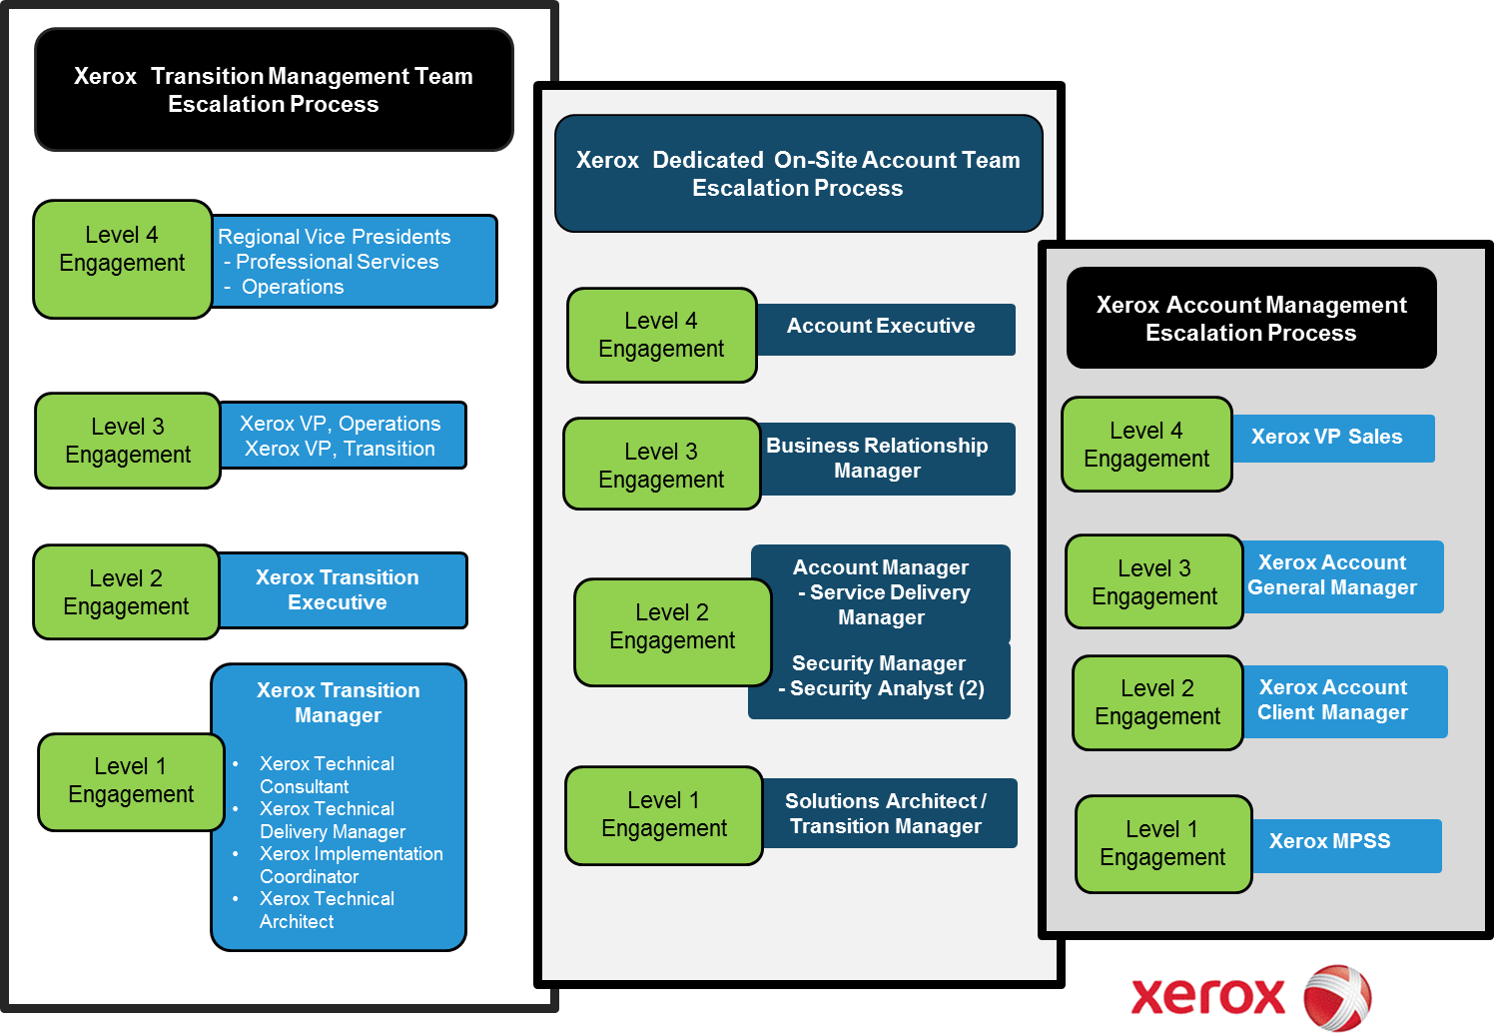

Figure 2. VITA Xerox Team
Xerox is also partnering with three SWaM (small, women-owned, or minority-owned) subcontractors to support further the VITA MPS program.
- NTS will provide local 24x7x365 Help Desk services along with networked printer and scanner break-fix service.
- Virginia Business Systems will provide HP and Lexmark networked printer catalog and HP and Fujitsu scanner catalog Devices.
- Cobb Technologies will provide the Canon/Océ wide format plotter catalog Devices as well as providing support on those Devices. The graphic below shows subcontractor team roles.

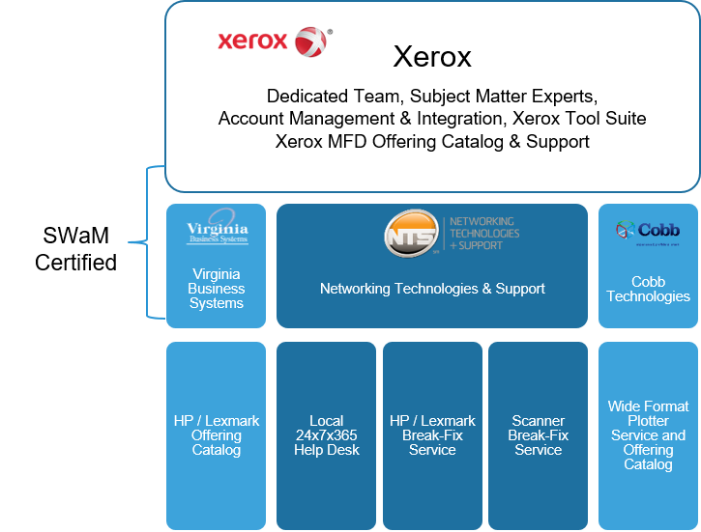

Figure 3. SWaM Partners
Xerox Personnel Training
Xerox will foster and enable a culture that advances an individual’s skills, knowledge, experience, and ultimately, his or her career. All Xerox employees receive mandatory training focused on continued personal skills development and necessary industry knowledge to better support the outsourcing services program. This training will typically include a minimum of 40 hours per year, or more regularly as the need arises, to share new product and services knowledge or skills enhancement. In addition, all site support staff and service delivery managers are required to do refresher training on Xerox Code of Conduct & Ethics Compliance annually.
Additionally, when Xerox hires an employee, the candidate’s skills, knowledge, and experience are critical factors taken into consideration. Those who become Xerox employees must possess, at a minimum:
- Proven competence
- Excellent customer satisfaction and interpersonal skills
- Demonstrated competency in PC applications
- Willingness to learn
Retention of people, as well as succession planning for key roles, are important for the efficient and effective provision of services at VITA. In order to attract and retain the best in the industry, Xerox will offer competitive compensation packages and career opportunities.
The GlobalTalent@Xerox platform that Xerox will provide to employees includes the following valuable personal and professional career management tools:
- Regular goal planning
- Formal management feedback
- Alignment to goals up and down the entire organization
- Posting for local, national and international roles
- Access to supplemental benefits to support
- Unplanned life events
- Savings plans
- Comprehensive medical, dental and pharma care
Xerox will offer Learning@Xerox to support continued employee education to advance professional goals and objectives. This repository will include over 10,000 courses for self-paced learning, formalize classroom learning and access to external classes and accreditations, including PMP and ITIL certification preparation.
Xerox has set standards of performance with respect to product training for Xerox’s technicians. Xerox will administer a qualification exam to service technicians to ensure they possess the prerequisite skills in electrical, mechanical, laser safety, and computer knowledge. A series of technician classes that includes safety, customer skills, and product training are then administered prior to any customer service delivery. Xerox product certification is required for all technicians, and a customer service request will not be dispatched to an untrained technician.
All Xerox VITA MPS staff will begin work with a kickoff meeting to review the program and program components. During this meeting, Xerox will consider all the training required for each position as well as information specific to this program. Xerox’s corporate Human Resources team will monitor training for Xerox’s entire team and ensure that training is up to date, relevant, and maintains Xerox’s team’s certifications. Xerox’s training database will allow Xerox’s HR team to pull up any training certifications as required. Anyone who needs to be re-certified will be notified one (1) to two (2) months ahead of time to allow for preparation.

Field Services and Technical Support Services
Xerox’s support model is vendor-agnostic and Xerox will service and provide supplies for Devices from other manufacturers.
Below, in Figure 4, is a map of the Xerox team’s current service coverage for Virginia. Xerox will provide a team of 99 service technicians that support the Commonwealth of Virginia. There are 85 Xerox technical service personnel providing support for Xerox Devices. Additionally, Xerox is sub-contracting with NTS to provide 14 service technicians for non-Xerox networked printers throughout the Commonwealth.

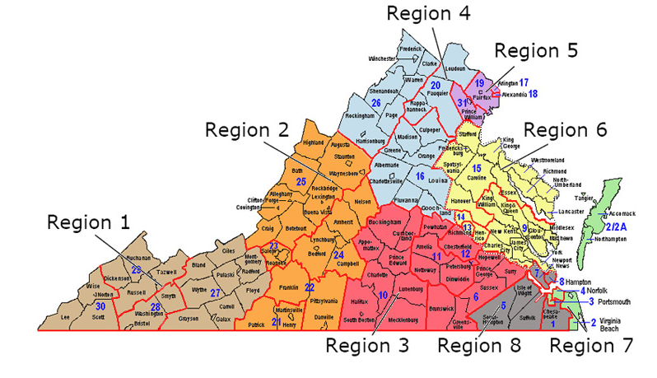
Figure 4. Map of Virginia Service Coverage

Xerox, in collaboration with their sub-contractor NTS, will provide certified technicians strategically located throughout the Commonwealth of Virginia. Following the completion of a service call, technicians will inspect other local Devices for functionality and validate with the point of contact that there no other concerns that need to be addressed.
Xerox, in collaboration with their sub-contractor NTS, will also provide service for the scanner population. Xerox, in collaboration with their sub-contractor Cobb, will service plotters.
All Xerox technicians are required to pass a 50-state background investigation, a drug test compliant with the United States Department of Health and Human Services (HHS) mandatory guidelines for federal workplace testing, are authorized to work in the United States, have a valid driver’s license and are subject to yearly motor vehicle audits. Xerox understands that employees are required to pass additional VITA required background investigations based on position and work location and Xerox will comply with the VITA Rules and Customer requirements for the background investigations. Xerox supplies company vehicles to the Field Service Technician population to assure proper transportation, ability to stock the needed parts for a first-time fix and SLA compliance.
Training will include additional product and software courses aligned to equipment requirements or geographical location.
All Xerox sub-contracted NTS technicians are required to pass a 50-state background investigation, 11-panel drug test, are authorized to work in the United States, have a valid driver’s license, reliable transportation and proof of insurance. Xerox understands that all subcontractors are required to pass additional VITA required background investigations based on position and work location and Xerox will comply with the VITA Rules and Customer requirements for the background investigations. Every Xerox sub-contracted NTS technician has a training career path that ensures they are continually upgrading and enhancing their technical skills to meet customer demands. Minimum requirements for the Xerox sub-contracted NTS Field Service Technicians are:
- CompTIA A+
- HP Accredited Platform Specialist (APS)
- Imaging and Printing Fundamentals, Universal Print Driver understanding
- Future Smart V4 firmware certification
- Color theory training
- Current family of Brother monochrome printer certification
- Lexmark monochrome training
Trouble Ticket Management
Xerox support is both proactive and reactive. Xerox’s Solution is powered by Xerox’s Software platform that discovers, tracks, configures, and manages with robust Device management tools and provides real-time monitoring of VITA’s fleet’s operations. By monitoring Devices and products remotely, Xerox will resolve issues proactively without any End User action required.
When onsite technical support is needed, requests for assistance will be placed through VITA’s MSI Help Desk. The Xerox Help Desk will provide a response by phone or email or as otherwise required with a locally operated customer care resource to receive requests for break-fix, supplies, relocations, or inquiries. If the Xerox Help Desk is unable to resolve an issue over the phone, an alert will be sent to a technician for resolution. The Xerox Help Desk will provide trouble ticket management and track all open tickets through to resolution and closure. To support the on-site technicians, Xerox will employ an integrated-service call escalation process that utilizes local field specialists along with 2nd-level technical support and development engineers for in-process service calls. Xerox also offers 24x7x365 phone support for the escalation of any customer support/performance issues. VITA’s MSI Help Desk can contact Xerox Help Desk 24 hours a day, seven days a week, 365 days a year. The Xerox Help Desk representative will log the call/issue and ensure the appropriate Xerox resource is engaged.
The Xerox Help Desk will remotely resolve problems, dispatch a service technician, order supplies, and schedule relocations or disposals in accordance with the SMM and VITA Rules. Based on the integration sessions held between Xerox, MSI, VITA and Xerox and MSS Provider, the Xerox team will provide the Help Desk workflow which is shown in Figure 5 below, which is a draft and will be finalized in the SMM.
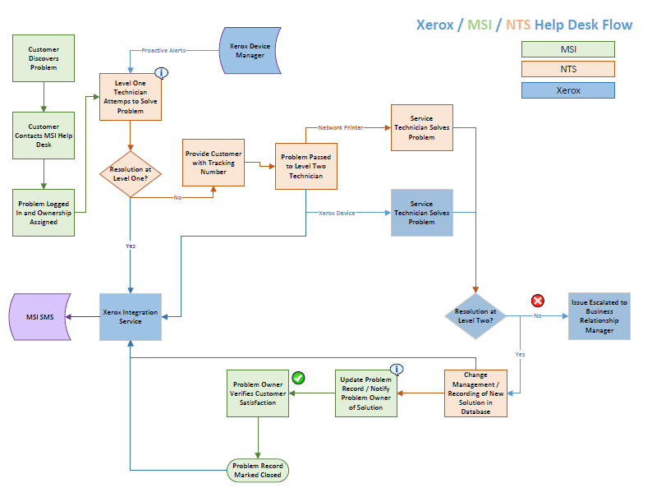
Figure 5. Sample NTS/Xerox 24/7 Help Desk workflow.

As part of Xerox’s Help Desk process, Xerox requests that the MSI provide the end user's full name, email address, telephone number, problem type, and location. If the request is for a hardware device the serial number, model, and any other details should be provided as well. This information serves to verify identity and contact information and identifies equipment location if applicable. After entering a service request, a ticket number will be provided either over the phone or via email and can be referenced when checking the status of the ticket through completion. Xerox requests the MSI agent contact the Xerox Help Desk in one of the following ways to report a problem: creating a ticket in the MSI SMS, calling the dedicated number or emailing the Xerox Help Desk who will then create a ticket. Xerox’s Help Desk system, XSM, will be integrated with SMS and provide VITA and MSI with one location to view and access Help Desk tickets. Xerox’s Help Desk technicians will closely monitor the XSM utility and respond to any alerts and tickets as required. When an XSM alert is generated, an automated email is sent to the Help Desk to generate a new ticket. When the Help Desk is called or emailed, the technician will open a Help Desk ticket request through XSM which will also create a ticket in SMS. An automated email is also sent to the requester providing the ticket details including ticket number and the assigned technician's name. Upon receipt of the ticket, the Xerox sub-contracted NTS technician will triage the ticket to determine the severity level and level of service required and assign it to the appropriate technician for remediation. Once the issue is resolved, the ticket will be closed, and the alert will be cleared. Resolving the ticket will show a resolution in SMS and will also generate an email to the original ticket requester letting them know that the ticket has been resolved. Upon ticket resolution, an automated email will be sent to the Customer, with full details of the work performed, and any corrective action taken. For escalations of Help Desk issues, the Help Desk technicians are trained in the escalation process and will immediately contact the Help Desk manager, via phone and email. The Help Desk manager will then reach out to the Customer to assess the situation, offer suitable resolution and take required corrective actions. If further escalation is required, the Help Desk Manager will escalate the issue to the Xerox Account Manager for further action as needed. If Help Desk manager is unavailable, escalations proceed to the VP of Integration Services for NTS.
Xerox’s Account Manager will oversee overall program management to ensure all issues are resolved promptly and will interface with Customer personnel or other suppliers as needed to effect resolution and ensure customer satisfaction.
End-user responsibility for printer related activities include the following:
- Serve as the key Device contact for receiving service and supplies
- Load consumables to include paper, toner, staples for all Devices
- Install customer replaceable units, which are drums, fusers, and waste toner cartridges
- Return of empty toner cartridge: Replacement toner cartridges will be shipped to Customers with a return shipping label included. Upon installation of the new consumable item the User will be responsible for placing the empty toner cartridge into the newly received box, sealing the box, affixing the return shipping label, and making any necessary arrangements to have the supply picked up by the appropriate shipping company
Xerox is responsible for installing printer maintenance kits on contracted Devices listed in the CMDB.
If Customers identify a need for suppliers or services then the Customer may place calls to the MSI Help Desk to request the supplies or service as needed.
The Xerox Help Desk is available to assist in problem resolution 24 hours a day, 365 days a year. If an after-hours issue is unable to be resolved remotely by the Help Desk, and onsite technical service is required, Xerox, along with Xerox’s sub-contractor, NTS, will provide optional after-hours onsite support upon request. Our after-hours support option is included in the rate card in Exhibit 4.1.
When it becomes necessary for a Xerox Technician to escalate an unresolved machine issue, Xerox employs an integrated service call escalation process that uses local field specialists, 2nd level technical support and development engineers to support on-site service technicians for in-process service calls. If the service technicians need to escalate issues further, the Xerox Account Manager will be informed and resolve the issue to closure. If necessary, the Xerox Account Manager will seek additional assistance and corporate support from the Xerox Account Executive.
2.2.1 VIP Support
Xerox will provide enhanced break-fix support for identified VIP Devices. Upon notification from the MSI Help Desk, the Xerox Help Desk will coordinate VIP support activities to meet the SLAs and customer satisfaction as defined in Exhibit 3.1 and Exhibit 3.2. Xerox will provide VIP support for VIP Devices in accordance with the SMM and VITA Rules.
WITO VIP coverage will be identified by VITA at time of award. Future VIP Device Support requests will be initiated and managed through the Service Catalog ordering process.

Hardware Services
Xerox will provide all Hardware that underpins the Managed Print Services solution, including printers, cables, and Consumable Supplies. Xerox will provide a wide breadth and depth of offerings to meet all customer requirements. This catalog will be comprised of multifunctional Devices, printers, scanners, plotters, and fax enablement across a variety of manufacturers including Xerox, HP, Lexmark, Fujitsu and Canon/Océ. Through Xerox’s team, Xerox will source, provision, fix and manage all VITA approved Devices across all VITA locations.
To ensure that agencies have a broad selection of product type and brand, Xerox will work collaboratively with MSI to populate the catalog with multiple OEM offerings. Xerox will make product recommendations based on their assessment of the VITA Environment. The Xerox Tool Suite as well as Xerox Print Management and Mobility Suite both support this multi-branded environment.
Prior to installation of new Hardware, the Xerox Solutions Architect will test all Managed Print Device platforms and provide a certified status to VITA, MSI, and MSS Provider upon completion. Xerox will provide test Devices of all of the different platforms in Xerox’s Certification Lab. Devices will be tested following all updates, refreshes and Patches. Additional testing will be performed as required.

2.3.1 Product Selection
Xerox will provide a combination of desktop, standalone, monochrome, color, single and multifunction Devices to meet both small and large workgroup needs. Multiple Xerox multifunctional Device models built on Xerox’s ConnectKey® technology will be provided, ranging from 25-70 pages per minute (ppm). Each multifunction Device will come with copy, print, scan, email, analog fax capability (one line), collating, mobile print functionality and global print drivers as standard features. Additional functionality such as, hole punching, booklet making, envelope kits, additional paper sources and other options are available for an additional charge as stated in Exhibit 4.1.. Along with the ConnectKey® technology, Xerox will provide the Xerox Print Management and Mobility Suite (XPMMS) for tracking usage by user level via enhanced accounting integration and card-based authentication and LDAP integration.
Additionally, Xerox has partnered with Virginia Business Systems to supply HP and Lexmark color and monochrome printers ranging from 28-70 ppm as well as HP and Fujitsu scanners. Xerox’s catalog will also include Canon/Océ wide format plotter product and support provided by Cobb Technologies.
ConnectKey® Ecosystem MFD Technology
The Xerox brand Devices provided to Customers will be the foundation for future security, productivity and automation tools to improve the way documents work for VITA. The Devices are on-ramps into existing workflows and processes, utilizing innovative apps and integration capabilities to help bring more convenience, productivity, security, and cost control to VITA. Xerox will provide Devices that have the ConnectKey® platform which include the capabilities described in figure 6 below:

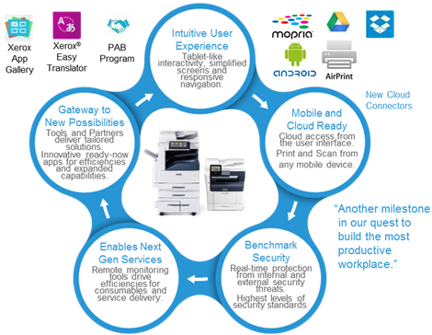
Figure 6. ConnectKey® MFD Ecosystem

ConnectKey® Unmatched Security
Xerox ConnectKey® MFDs will feature industry-leading security that has been achieved via partnerships with Cisco and Intel Security (formerly McAfee). The Xerox provided ConnectKey® technology will enable multifunction Devices to protect themselves from potential outside threats by using whitelisting technology, ensure only safe, pre-approved files or functions are executed on VITA’s Devices.
ConnectKey® Universal Platform
ConnectKey® is a consistent platform and interface provided across a broad range of Xerox Devices. The common User experience regardless of ConnectKey® product means users have the same experience using print drivers, Device interfaces and features on the entire portfolio of ConnectKey® products. Users can check the status of supplies and jobs without having to go to the Device.
ConnectKey® True User Productivity
Xerox ConnectKey® controllers enable multi-tasking capabilities by performing image processing, receiving, programming ahead, processing queues, and transmitting functions simultaneously. This will be a key benefit that ensures print productivity as VITA optimizes the print environment and more volume shifts to MFDs. Additionally, ConnectKey® combines technologies, capabilities, and extensibility. For example, ConnectKey® will work with Customer REDACTED to simplify and streamline the way Users scan, capture, and store VITA’s paper-based documents. Users can route documents directly into the precise document repository folder, just as Users would from their PCs. At the MFD, Users can browse to the folder, name the document, and add any key indexing information before the Users scans.
Xerox Print Management and Mobility Suite (XPMMS)
Xerox Devices with ConnectKey® provide Wi-Fi and Wi-Fi Direct printing capabilities, plus Apple® AirPrint®, Google Cloud Print, Xerox Print Service Plug-in for Android, Near Field Communication (NFC) Tap-to-Pair and Mopria®.
For mobile printing, Customers can opt to purchase through this contract the cloud-based Xerox Print Management and Mobility Service or Xerox Print Management and Mobility Suite for an on-site, server-based solution.
The Xerox Print Management and Mobility Suite (XPMMS) provides added control by tracking usage by each user via enhanced accounting integration, enabling chargebacks, and provides for authentication and LDAP integration.
The XPMMS solution provides the following:
  - Cloud-based Xerox Print Management and Mobility Service will provide quick, easy setup and management. Xerox hosts the service on a REDACTED platform
  - Supports secure submissions from any email-enabled mobile Device, including Google® Chromebooks, iOS, Android, Windows® 8 tablets/laptops and other laptops with a print-driver experience via the Xerox Mobile Print Cloud App
  - Supports printing via Apple® AirPrint® to any brand of printer (Xerox and non-Xerox), old and new
  - Enables Users to print without adding Software to mobile Devices/laptops and with no IT intervention
  - Supports most common file formats including native support of Microsoft Office Support and support of web pages, Adobe® PDF, Photos (PowerPoint®, Word, Excel®, PDF, Images, JPG, HTML) and Apache OpenOffice
  - Provides a flexible choice of print workflows enabling popular ‘push’ email-style printing or ‘pull’ follow-style workflow
  - Enables end users to establish access controls that allow or block mobile print requests from users, groups and more, via a centralized solution for access management
Evolving Hardware Offerings / Managed Print Device Selection Determination
Xerox will continually evolve Hardware offerings as new product platforms are launched. As new technologies become available, Xerox will perform a cost/benefit analysis and together with VITA and MSI determine if they are an appropriate fit for the COVA Environment. Xerox will make recommendations for new offerings that reduce costs and improve business functions and productivity. Xerox will test the offerings and certify their compliance to VITA Rules and other VITA requirements prior to adding them to the catalog. New product launches will be a continued evolution of the innovative ConnectKey® platform.
Furthermore, Xerox will coordinate with the MSI to populate the Service Catalog to ensure a breadth of choices to satisfy VITA and Agency business needs. To augment the Xerox portfolio of Devices, HP and Lexmark printers and HP and Fujitsu scanners have been selected to be included in the catalog as well. Xerox will collaborate with VITA and the MSI to populate the catalog with final Device offerings.
Proof of Concept/Test-Devices
Xerox will provide VITA with innovative solutions over time through Xerox’s research labs and research and development teams. Xerox will provide state-of-the-art proof of concept Devices to showcase Xerox’s newest technologies. This will be done in the Xerox provided testing and certification lab. Specific parameters will be developed in collaboration with VITA and MSI.
Compliance with VITA Rules, Architecture Standards, and Hardware Manufacturer Recommendations
Xerox’s Solutions Architect and Security Manager will ensure that Xerox’s team and equipment comply with all VITA Rules, architecture standards, and Hardware manufacturer recommendations. Xerox will do this through a combination of Software tools, Xerox internally developed guidelines, and subject matter expertise on the Hardware. Compliance and audit checks will be done on a regular basis to ensure compliance is maintained. In areas where compliance is lacking, Xerox will make recommendations and provide solutions to ensure compliance.

2.3.2 Refresh and Replacement
As part of the refresh phase, Xerox will provide a Currency Plan that ensures Devices that comply with manufacturer recommendations and VITA Rules and are not outside of OEM support.
The Xerox software tool suite will give VITA real-time input about current Devices connected to the network. This will enable Xerox to provide proactive repair or replacement of Device components. By monitoring Devices and products remotely with the Xerox Tool Suite, Xerox is able to resolve issues proactively without any End User action required. Maintenance services will also be provided reactively, responding to End User requests. Whether proactive or reactive service dispatch, Xerox will repair or provide functioning replacements for failed, damaged, or failing components including toner, fusers, rollers and power cords. Xerox’s service technicians will be fully equipped and stocked with the replacement parts VITA needs. By leveraging the Xerox software tool suite, Xerox’s Help Desk representatives will prepare the service technicians about the issue so that they have all parts needed to ensure equipment is functional.
Based on Xerox’s integration sessions with MSI, VITA, and MSS Provider, Xerox will make Security compliance a key priority of the Currency and Technology Plans.
Total Satisfaction Guarantee (TSG)
The Xerox Total Satisfaction Guarantee is executed completely at the Customer’s discretion and is additional to the repair and replacement requirements of this contract.
If VITA is not satisfied with any Xerox-brand Equipment delivered under this Agreement for any reason, Xerox will replace it without charge with an identical model or, upon agreement of Xerox and the Customer, with Xerox equipment possessing comparable features and capabilities. This Guarantee applies only to Xerox-brand Equipment that has been continuously maintained by Xerox under this Agreement or a Xerox Full Service Maintenance Agreement. For Equipment installed prior to Commencement Date, this Guarantee will be valid for 1 year after installation. TSG will expire at the end of the Term of this Agreement.
Special Production Equipment (“SP Equipment”), which includes iGen3, iGen4, and Xerox Continuous Feed are excluded from the guarantee described above and will follow the process below for the TSG. The TSG is not applicable during the first 180 days of install for SP Equipment. After this initial period, if the SP equipment does not perform up to the expectations set in the VITA Expectations Document (which is a document developed by Xerox and approved by Customer prior to delivery of the SP Equipment) for a period of 90 days, at the customer’s request, Xerox will replace the SP equipment with like or similar equipment.
Refresh Plan
In collaboration with MSI and VITA, Xerox will provide a Refresh Plan that will include refresh options for Devices including MFDs, printers, scanners and plotters. Particular attention will be paid to prioritize the oldest Devices and those with the highest business impact. Data gathered during Xerox’s assessment phase will populate a visual dashboard that allows for easy identification of cost outlier Devices. The assessment data, combined with Xerox expertise and VITA, MSI and MSS Provider requirements will shape the desired future state design for the Refresh Plan. In addition to numerous product options, Xerox is providing product refresh at yearly intervals with a minimum of 20% of the fleet refreshed each year and based on a 60-month term for the new product placement. Additional terms are available where required by VITA and will be agreed to by the parties. For needs beyond the annual 20% refresh, additional options will be evaluated with VITA to establish an acceptable refresh schedule. As part of Xerox’s requirements analysis, Xerox will evaluate all Systems against current Systems Security standards, VITA Rules and SMM rules to ensure compliance.
Xerox will standardize the VITA fleet during Xerox’s refresh phase. Xerox has chosen Xerox ConnectKey® technology platform as the baseline for VITA’s MFD environment to provide a universal user experience and IT administration and security. Optimization opportunities based on utilization, cost, and redundant capabilities will be evaluated and presented for VITA consideration.
Xerox will present a technology Refresh Plan to VITA. This Refresh Plan will serve as a plan to begin migrating Agencies from aged technology to the latest technology available in the multi-vendor offering catalog. Xerox has multiple tools at their disposal that they will use to analyze current equipment inventory health and which will allow Xerox to focus on project planning to yield the greatest results within the shortest amount of time. Upon review of the existing equipment population provided by VITA, the following equipment statistics were identified:

VDOT
DMV
DSS
DJJ
VEC
TAX
DOE
DARS
DEQ
ABC
OTHERS
MPS Coverage
No MPS Coverage

Figure 7. Statistics Guiding Proposed Refresh Plan
Xerox’ believes that agencies currently not under managed print or with aged equipment are priority pursuits for the early transition and will provide a Refresh Plan that reflects such. The following agencies have been identified as candidates for phase one:
- Virginia State Police
- Department of Corrections
- Department of Professional and Occupational Regulation
- Virginia Department of Agricultural and Consumer Services
- Virginia Information Technology Agency
- Virginia Department of Health
Xerox will present the year one Refresh Plan to VITA for acceptance. Additionally, Xerox will collaborate with VITA/MSI to prioritize additional Agencies to begin the assessment process. While conducting the Agency assessments, Xerox’s process will include a meeting with the Agency sponsor that will allow specific Agency requirements to be added to the objectives already set by VITA/MSI. In Xerox’s experience, when an assessment is conducted in a non-Managed Print environment, the employee to Device ratio is between 2:1 – 3:1. Future state optimized environments typically can be redesigned to result in a ratio of 5:1 – 8:1. Xerox accomplishes this change in print culture by partnering with the Agency sponsor. Xerox’s focus is not only to reduce the number of print Devices, but also to redefine print practices where necessary, distribute new equipment within a defined walking distance of users, and place the correct Device in the correct business environment.
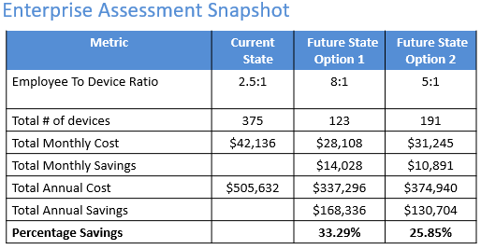
Figure 8. Example of Enterprise Assessment Results Snapshot
Agency assessments will occur simultaneously, and recommendations will be made for each Agency to refresh their technology. Based on Xerox’ experience in deploying Managed Print Services for large organizations, following this process will highlight areas of opportunity for equipment optimization, the reduced cost associated with print, and increased end-user satisfaction.

Security
Xerox is familiar and will comply with VITA Rules and has a proven track record of meeting VITA requirements. Xerox’s current initiatives include Xerox and third-party Devices approved and in use on the VITA and Executive Branch Agencies network. Xerox will prioritize Security in Xerox’s MPS Solution for VITA by:
- Utilizing Xerox’s ConnectKey® platform
- Dedicating an ITIL and CompTIA Security+ certified Security Manager
- Utilizing Xerox Print Security Audit Service (XPSAS)
- Utilizing Xerox Print Management and Mobility Suite (XPMMS)
Xerox understands VITA’s security concerns and requirements. Therefore, as part of the VITA solution, Xerox will have a dedicated on-site security Manager and two Security Analysts. The Xerox Security team will provide and comply with the following:
- Coordinating Security Management activities with VITA, MSI, and MSS Provider
- Ensuring documentation is updated including SMM and other documents containing security information,
- Training Xerox staff on VITA Rules and Customer security standards
- Ensuring access management is appropriate for staff and users
  - Immediate removal of privileges for users no longer with Xerox
  - Correct Customer rights based on roles and locations
  - Separate accounts for administrator access versus system access
  - Implementing safeguards against unauthorized access, destruction, loss, or alteration of Customer data
  - Role-based access to monitoring and reporting interfaces
- Auditing of Security measures by VITA or designated party
- Manage MPS Security incidents as defined in section 2.4.1
Configuration of Devices
Xerox will protect all VITA’s stored information using the highest levels of encryption. VITA can delete any processed or stored data that is no longer required and such deletion will comply with VITA Rules.
A digital certificate is required on the Device to enable encryption for specific types of workflows, such as file transfer, web interactions, Device management, or scan file creation. Xerox MFDs come from manufacturing with REDACTED, and the system administrator can configure each Device with certificates generated by an internal customer provided or external certificate authority such as REDACTED. The System Administrator can also create a new self-signed certificate on the Device itself.
For VITA, Xerox will use hard drive disk encryption, employing REDACTED to secure user data. The key is not stored on the drive, and is in Volatile Memory and regenerated at boot-up. Disk encryption is used to prevent any User artifact data that might remain on a disk drive following any copy, print, scan, or fax transaction from being discovered by a malicious individual that might remove the disk drive from the Device for forensic examination. Disk encryption coupled with Disk Image Overwrite makes it virtually impossible for any data to be discovered on the disk drive. Xerox will comply with the Security configurations defined in the VITA Rules and SMM for any Devices prior to placement on VITA’s network.
ConnectKey® Platform – the Most Secure MFD Technology in the Industry
ConnectKey® Technology utilizes a comprehensive set of capabilities that prevents malicious attacks, the proliferation of malware, and misuse of/unauthorized access to the printer, whether from transmitted data or direct interaction at the Device. All possible access points are secure, including the user interface and input ports accessible to walkup users as well as PC, server, mobile Devices or cloud connections. Xerox ConnectKey® Technology runs a comprehensive firmware verification test, either at start-up or when activated by authorized users. This provides alerts if any harmful changes to the printer have been detected. REDACTED technology will constantly monitor for and automatically prevent any malicious malware from running. Xerox’s ConnectKey® Technology will provide capabilities to prevent intentional or unintentional transmission of critical data to unauthorized parties.
Xerox will provide a REDACTED extension. The REDACTED extension allows MSS provider IT administrators to unify security management across endpoints. It integrates with Xerox MFDs to receive threat events. Xerox’s certified REDACTED extension provides visibility of the entire fleet of Xerox Devices. It allows monitoring and enforcement of security policy compliance by displaying over 50 security settings, port, and version status, and provides for Software updates. Through the REDACTED, Xerox will provide comprehensive reporting capabilities with preconfigured queries and a custom report on the Xerox MFDs.
Xerox will measure performance against VITA requirements and international standards with certifications such as Common Criteria and FIPS 140-2.
Xerox MFDs will provide multiple layers of security in each system of the Device (copy, print, scan, and fax) which are firewalled separately inside the Device. Xerox MFDs will utilize very high levels, 128-bit and 256-bit, of encryption.
The ConnectKey® MFDs provided by Xerox are Common Criteria Certified, and the following Security features have been validated by that certification:
- Image Overwrite –Is used to delete the used document data in the internal hard drive completely. Immediate Image Overwrite causes the data to be overwritten with fixed and random data after any function of copy, print, scan, or fax is completed. On-Demand and or Scheduled Image Overwrite is performed immediately when the admin or other privileged user requests it, or when they request it to occur at a specific time, such as when the use of the Device is low.
- Hard Disk Data Encryption - The document data and the Security audit log data are encrypted before being stored into the internal hard drive when operating any function of copy, print scan, fax, or configuring various Security function settings.
- System Administrator’s Security Management - This function will allow only the system administrator identified and authorized from the control panel or system administrator client to refer to and change the Time, Object, Event (TOE) Security function settings.
- Security Audit Log - The important events of the Device such as configuration change and user operation are traced and recorded based on when and who operated what function.
- Internal Network Data Protection - This function protects the communication data on the internal network such as document data, Security-audit log data, and Device setting data.
- Fax Flow Security - This function prevents unauthorized access to the Device or the internal network via the Fax board from a public telephone line.
- IP Address Restriction - This function will allow only approved IP addresses to communicate with specific network clients; SSL/TLS for secure web submissions and network authentication to restrict access to scan, email, and network fax features.
In addition to these features on Xerox MFDs, all Xerox Devices (single and multifunction Devices) will be delivered with hard disk encryption enabled by default and each Device will be configured for secure network communication during Device setup/configuration as part of Xerox’s ongoing approach to complete system Security and best practices. Additional configuration items for Security will be reviewed with VITA, MSI, and MSS Provider during Implementation. These configurations will be applied and monitored with the support of the Xerox Security Manager dedicated to VITA. Xerox will ensure Devices comply with current and future SMM and VITA Rules prior to installation on VITA’s network.
Dedicated Security Manager
Xerox’s dedicated Security Manager will be ITIL and CompTIA Security+ certified, provide oversight to Security measures, and needs of the program. The Security Manager will respond to Security issues, threats, and provide resolutions in a timely manner. In addition, the Security Manager will assess, implement, and manage the Security of all MPS components managed under this program. The Security Manager will:
- Align all activities to VITA Rules and SMM
- Respond to Security incidents and initiate corrective actions in respect of any potential or actual Security issues, risks, or noncompliance in accordance with the SMM and VITA Rules
- Provide audit status report monthly or upon request
- Identify Security improvement opportunities and make recommendations to MSI and VITA
- Implement Xerox Print Security Audit Service tool to monitor changes to print Security blueprint
- Perform and support Security audits including evaluation of remediation plans and results
- Provide role-based access to monitoring tools including MSI and MSS Provider required team members
- Train and educate Xerox associates to meet the requirements of the SMM and VITA rules
- Transmit environmental logs from all Devices to the MSS provided SIEM system, or other SIEM system as required by VITA
- Ensure Security Management activities are kept up to date, managed effectively, have the appropriate tools and access, and are reported in accordance with the SMM and VITA Rules.
Xerox will comply with the identification of users no longer with Xerox and remove their access to VITA data and the network. The Account Executive and Security Manager will monitor user access rights for Xerox employees. Xerox will comply with providing Security audit status, failures, health check, internal assessment, or internal Security audit violations.
Xerox Print Security Audit Service (XPSAS)
Xerox has included, as part of VITA’s solution, Xerox Print Security Audit Service (XPSAS). XPSAS supports the requirements to secure Devices across VITA’s enterprise. For all Devices that are compliant with the current MIB (Management Information Base) standard, XPSAS provides ongoing reporting to show compliance or highlight gaps that Xerox will address in collaboration with VITA and the other STS as may be required. XPSAS supports third-party Devices at various levels depending on the manufacturer and models. For new Device installation, Xerox will ensure Devices are supported by XPSAS for security configurations.
Xerox will create a security baseline that is compliant with VITA Rules. Xerox’s dedicated Security Manager will review VITA’s Rules to configure and drive consistent and uniform Device behavior across VITA’s Managed Print Services environment. A configuration set will be created by Xerox, matched against VITA Rules to ensure compliance, and deployed to a single Device, group of Devices or VITA’s entire MPS fleet through Xerox Device Manager (XDM).
XPSAS reports are automatically generated to assess Device compliance to the VITA Rules and will showcase proof of compliance and/or calls to action for remediation, if necessary. Xerox will provide these reports to VITA.
Device security features such as access and control, which enables and disables functions and access levels on all networked Devices, User data encryption, hard disk drive administration and firmware support will be provided by Xerox.
XPSAS Firmware Maintenance
Another key aspect of the Xerox Print Security Audit Service (XPSAS) is the maintenance of Device firmware. The current system maintenance and monitoring cycle will drive normal Patch management when there is no exploitation of a vulnerability identified. If exploitation of a vulnerability is identified through the XPSAS audit cycle, internal risk assessment and escalation processes will drive an accelerated security Patch cycle.
Xerox upgrades firmware when XPSAS finds an issue with the original certified firmware. Once the new firmware is certified by VITA and the MSI, Xerox will perform firmware updates in three ways:
- Automated Updates Over the Network - Xerox will utilize XDM to perform automated firmware updates to Devices eligible to receive updates in this manner.
- Manual Updates Over the Network - For Devices that cannot receive firmware updates deployed from XDM, updates will be deployed directly to the Device via the web interface over the network.
- Manual Updates at the Physical Device - For Devices that cannot receive firmware updates over the network, updates will be deployed at the physical Device.
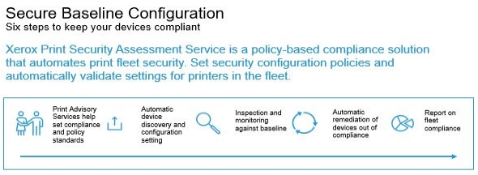
Figure 9. Xerox Print Security Audit Service

Xerox Print Management and Mobility Suite (XPMMS)
XPMMS is another layer in security in the Xerox MPS Solution for VITA and will provide user-based authentication for security, auditing, and tracking. Users authenticate at the card reader-enabled Devices using their existing Security badges and authorizations can be customized based the user’s profile. The data collected creates an audit trail of activities. If the follow-on print capability is purchased by the Customer, users print to a holding queue and release jobs at any of the desired card reader-enabled Devices on the network by badging. The User’s active print jobs are displayed, and the User is able to select the desired jobs to print. With this method, unclaimed documents no longer will litter printers for anyone to see or become waste.
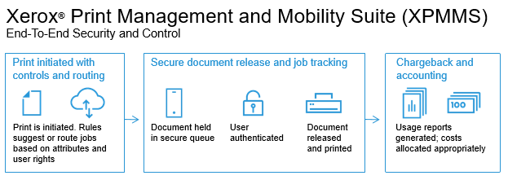
Figure 10. Xerox Print Management and Mobility Suite (XPMMS)
Post-award, Xerox will evaluate each Agency engagement to validate if XPMMS is the right fit to meet VITA goals. If XPMMS is not the best fit, Xerox will recommend alternative solutions as needed to meet a specific need, a requirement that is defined during the assessment, or during the presale process for Agency engagement.
XPMMS provides a vendor-agnostic approach to print security, flexibility, and job tracking at the End User level. XPMMS is a set of services powered by print management and Security Software from Xerox. It includes secure document release capabilities via badge-reading, “follow-me” print solution and mobile print to enable convenience printing, systematically implements print governance through rules and routing, and supports authentication requirement on each Device. These features help to ensure security by the User being present at the Device while the document is outputted reducing the risk of others seeing the content or accidentally picking up the unclaimed printed output from a table near the Device.
Hosting Environment Security
Xerox follows industry best-practices and implements a layered approach to information Security and risk management.
Xerox’s hosting operations have been ISO 27001 certified since February 2007. Xerox’s ISO certification provides assurance to Xerox’s customers that Xerox is committed to information security, and implement common processes, continual improvement, risk assessment and treatment, proactive monitoring, change management, logging, and auditing. Xerox will maintain the ISO 27001 certification during the term of the contract.
Data Security
Protecting Customer data is paramount to both the customer’s and Xerox’s success. Xerox’s data security model revolves around the core security services of confidentiality, integrity, and availability. By creating robust policies, processes, and standards to address these core services, Xerox provides data security in multiple ways to protect VITA’s data. Xerox will comply with VITA Rules to ensure Customer data is secure and protected from destruction, loss or alteration.
Application Security
Xerox will follow industry and government standards in its application development lifecycle to ensure that information is protected. Developers are trained in and follow secure coding practices. The code is reviewed and scanned for vulnerabilities, using both manual and automated testing procedures, to proactively address potential risks and vulnerabilities in applications. Scanning and application penetration testing are performed regularly to ensure that data is secure from unauthorized access. Xerox will comply with VITA Rules and SMM to ensure Software is properly configured and functioning prior to releasing to Customers.
System Security
The information systems that host Customer data will be hardened and according to VITA Rules and follow a strict configuration management process to ensure that all Patches, Software configurations, and anti-malware tools are updated in a structured, safe, and timely manner. Both system and application events are centrally logged, protected, and reviewed to assure that all systems are functioning as intended.
Furthermore, all data is replicated in real-time to an offsite data center, so it is always available when needed. Industry standard encryption technologies are utilized to assure confidentiality in transit, as well as at rest.
Network Security
Xerox will use hardware appliances such as firewalls and intrusion prevention systems to prevent unauthorized access to customer data as well as to stay notified of any attempts to compromise the environment. Network attacks are mitigated using multiple state-of-the-art techniques, including dynamic filtering and active verification.
Physical Security
The data center implements a wide range of security controls including fences and specialized lighting, cameras, biometric scanners, and physical Security guards. This provides a multi-level model of Security to prevent unauthorized personnel from entering Xerox’s data center.
Environmental Security
Xerox understands that availability is the primary focus of environmental security and will utilize redundant generators, air quality control mechanisms, and state of the art fire suppression technologies to ensure that VITA’s data is always available when VITA needs it.
Governance
Xerox follows industry best practice and guidelines around information Security management including those outlined in the following standards and frameworks: Sarbanes Oxley, ISO27001, NIST, ITIL, and Safe Harbor.
Xerox will implement Xerox’s own governance process for this solution. The Xerox Management Audit Committee has been establish under a Xerox Corporate Accounting sub-policy, which is part Xerox Internal Control Framework which is maintained by Corporate Internal Control under Accounting & Finance.
The Xerox Management Audit Committee will ensure that:
- There exists a well-designed and implemented Internal Control Management Process (ICMP)
- Controls are properly designed and operating effectively
- There are appropriate visibility and emphasis on significant control related issues aligned to the achievement of Xerox’s business objectives
- The impact of these controls ensures business changes including new systems are monitored through this process
The Xerox Engineering Services and Support (ESS) Information Security Management System has been certified by BSI to ISO/IEC 27001 under certificate number IS 514590.
General Security Compliance
Xerox will comply with all security tasks, the SMM and VITA Rules. These include the following:
- Devices are encrypted and functioning for use by Customers. All Device models that are provided by Xerox are equipped with hard disk encryption and are tested prior to installation. Following successful testing, Xerox’s team will do a desk-side installation where further security features such as a self-signed certificate and network security features can be configured.
- End User Devices are properly configured and functioning with all required security Software and Device configurations, in accordance with the SMM and VITA Rules, prior to releasing to Customers. Xerox’s Security Manager will verify that all End User Devices are configured correctly and functioning as well as double-checking security Software and Device compliance to all VITA and SMM rules. This will be done in Xerox’s certification lab where on-site testing will be performed. All new models considered for placement in the VITA solution will be vetted, tested, and certified by Xerox’s Security Manager to ensure compliance with SMM and VITA Rules. The Security Manager will ensure the VITA approved security image is compliant.
- Appropriate rights and permissions associated with End User Devices and related tools are assigned in accordance with the SMM and VITA Rules. Working closely with VITA, MSI, and MSS provider, Xerox’s Security Manager will build user profiles with specific rights and permissions assigned to each profile. This will be done to make sure that the appropriate level of access and rights are given to the right individuals. Xerox will verify any User requests for rights and permissions with VITA and MSI prior to granting access. Xerox’s Secure Print Management Suite requires authentication of Users for secure printing anywhere without putting information or data at risk and provides user-based job tracking so that administrators can track print usage on a per-user basis.
- Up-to-date Xerox User List, ensuring inactive users, no longer with Xerox, have access removed immediately in accordance with SMM and VITA Rules. The Xerox team will maintain an up-to-date Xerox User List and remove any users who no longer supporting this program on a timely basis. Access will be double-checked following removal to ensure that removal was completed. This process will be done in accordance with SMM and VITA Rules.
- Personnel are trained in security requirements within Managed Print environment including VITA Rules, Agency-specific policies, applicable Federal Regulations. The Xerox team’s training will begin with a program kickoff to review all security requirements and program overview that will include a review of VITA Rules, Agency-specific policies, and applicable Federal Regulations. Training will also be developed for new employees with this information as well.
Upon any updates to VITA Rules, Agency policies, or applicable Federal Regulations, Xerox will update the training provided to all employees. Refresher courses will be held on an annual basis, and Xerox will track all employees training to ensure compliance.
- Maintain Administrative and System accounts. The Xerox team maintains administrative and system accounts by doing frequent reviews. The Xerox Security Manager will maintain administrative and system accounts during the life of the contract and manage this process.
- Hardware and Software comply with Authentication and Security Requirements. Xerox uses rigorous standards defined by Xerox’s Security Manager with the assistance of VITA to ensure that all Software and Hardware comply with authentication and security requirements in accordance with the SMM and VITA Rules. Regular audits will be done to ensure that Hardware/Software maintain compliance. When there are updates to authentication, security, SMM, or VITA Rules, the Xerox team will use VITA approved security checklists to ensure that Hardware/Software maintain compliance or take immediate action to remedy issues.
- Environmental Logs from all Devices are transmitted to SIEM system. Xerox will ensure environmental logs from all Devices are transmitted to the MSS provided SIEM system, or other SIEM system required by VITA, in accordance with the SMM. These Device audit logs can be retrieved and sent to the designated VITA repositories and made available to designated VITA/MSI personnel as required, pending post-award details on intervals for statewide archiving or Agency-specific policies.
- Coordinate efforts to ensure Security Management activities are kept up to date, managed effectively, have the appropriate tools and access, and reported to comply with SMM and VITA Rules. Xerox will coordinate efforts through regular Security communications meetings, where the team will discuss security management activities, and review tools and access. The Security Manager will work closely with VITA, the MSI, the MSS and others as required by VITA to keep abreast of any security changes.
- Xerox will identify security improvement opportunities and provide recommendations to MSI, MSS Provider, and VITA in accordance with the SMM. This process will include recommendations from best practice guides and secure installation and operation Xerox manuals for multifunction and single function printers. These manuals are available online on Xerox’s corporate website. Xerox recommends that both VITA, MSI and MSS provider designated personnel to subscribe to the available RSS feeds to keep up to date on any security releases from Xerox. Xerox will comply with VITA, MSI, and MSS provider to develop innovative tools and VITA Device profiles for new Devices being delivered. The Security Manager will update a Device configuration baseline that enables the solutions within the environment while adhering to VITA Rules and SMM policies.
- Xerox will comply with VITA, MSI, and MSS provider to establish, maintain, and support mechanisms to safeguard against the unauthorized access, destruction, loss, or alteration of Customer data on any component of Xerox’s proposed solution. Xerox is aware of and will comply with the guidelines established in the VITA Rules on the use and protection of Customer data and how that pertains to Hardware and Software of the proposed solution. Xerox will comply with VITA, MSI, and MSS provider to perform any corrective or prescriptive actions/solutions to protect information during the life of the contract. VITA, MSI, and MSS provider should be aware that following best practice security guidelines for output Devices would provide the necessary safeguards to protect information and be compliant with IRS 1075 guidelines. During post-award discussions, Xerox will establish implementation and steady state Device and solution configuration parameters to safeguard the data and provide the desired functionality required by VITA, MSI and MSS Provider and the specific Agency involved with the solution.
For example, the proposed Xerox Solution will have Xerox Print Management and Mobility Suite (XPMMS) as the mechanism to enable secure print release to meet one of many options for protecting customer information. The service described here will hold a job until a User authenticates at the Device and then the output is delivered to the exit tray, preventing unauthorized access to the printed document. The XPMMS is an enterprise Print Management and Mobile Print platform that enables active directory (AD) integration, provides reporting, authentication to the Device for secure print release and walkup functions, authorization to use features, provide identify management, and accounting to provide detail of Device activity.
- Xerox provides, deploys, and maintains a solution to protect Devices that are outside VITA Network, e.g. devices connected to the Internet, in accordance with SMM and VITA Rules. Xerox will do this through Xerox’s XPMMS and with oversight from Xerox’s Security Manager.
- Xerox will perform and support Security audits to check the effectiveness of the Security procedures and controls in accordance with the SMM and VITA Rules. Using Xerox Print Security Audit Service (XPSAS), Xerox will maintain the Xerox fleet with XDM. The XDM will allow Xerox to audit the fleet for compliance with to the default-security configuration profile apply the default security profiles as required by VITA Rules, manage Device firmware/software, and restore Device settings. Any compliance gaps will be highlighted and corrected by Xerox. The XDM can assist in the collection of the audit logs for VITA Devices. Xerox will use the data collected from the XPSAS to recommend remediation actions and will review compliance during a regular cadence of business reviews. Audit logs can be stored on VITA designated repositories.
- Xerox will initiate corrective actions in respect of any potential or actual security issues, risks, or noncompliance in accordance with SMM and VITA Rules and as directed by VITA, MSI, and MSS Provider. Xerox will follow the VITA escalation and priority-ranking procedures. All security issues will be brought to the attention of the Xerox Security Manager who will handle these issues. If the issue still exists, this will be escalated to the Account Manager and Account Executive. The VITA, MSI, and MSS provider will be notified in a briefing/report of these issues as well as Xerox’s solution/corrective action or steps are taken.
- Audit Status Reports will be detailing ongoing work and actions identified and completed in accordance with SMM and VITA Rules. The Xerox Security Manager will work closely with the team to develop status reports and provide these reports as required to VITA, MSI, and MSS provider. These reports will be accompanied by a high-level summary of the reports and any issues/progress/or other items that need to be highlighted.
- Xerox will continue to implement, operate, and maintain the approved Cross-Service Tower solutions that meet all VITA’s virus protection requirements in accordance with the SMM and VITA Rules. To ensure full security compliance, the Xerox Security Manager will be responsible for creating, implementing, and managing the security standards as agreed upon by all parties.
- Xerox receives notification alerts of malicious events in real time. Upon receipt, Xerox takes immediate steps to assess and remediate these events in accordance with SMM and VITA Rules. Following Xerox’s Security Plan, Xerox will raise immediate awareness of these issues if the Security Manager cannot resolve them immediately.
- Recommend new Supplier security tools included as part of the Services (including any Equipment and Software products) that would reduce malware infection on workstations or improve the cleanup of infections on workstations and decrease the need for reimaging workstations. Following Xerox’s environment assessment, inventory and review of current Software/Hardware and toolsets Xerox will provide a recommendation, if Xerox sees any areas where security, productivity, and efficiency can be increased and/or cost decreased. In addition, Xerox will analyze and review any security issues/threats and Help Desk requests to identify areas where new security tools may be effective. This process will be revisited for any necessary updates.
- In coordination with the MSI, leveraging new Supplier security tools that would improve VITA’s business processes and performance. Xerox will work closely with MSI and VITA throughout the life of the contract. If new Supplier security tools are implemented, Xerox will proceed with implementation in close coordination with MSI, including scheduling and providing notification of any impacts there may be on the environment during the implementation. The Xerox Security Manager will develop VITA/MSI approved security standards for network connected printers and will update this process as needed on a regular basis.
- Maintain the technical and functional specifications and requirements for the Supplier security tools and any interfaces in accordance with the SMM and VITA Rules. Xerox’s Security Manager and Xerox’s Solutions Architect will ensure that all technical and functional specifications and requirements for the Xerox security tools and interfaces are in accordance with SMM and VITA Rules. In addition, Xerox will work closely with MSI to provide assurance and status throughout this process.
- Educate and train Supplier personnel and support professionals in the use of Supplier security tools in accordance with the SMM and VITA Rules. Introductory and refresh training will be conducted and provided to Xerox team members and support professionals in the use of Xerox security tools in accordance with SMM and VITA Rules. Training materials will also be provided and be made easily accessible for reference.
- Provide role-based access to monitoring and reporting interfaces for the VITA security tools. Xerox’s security tools currently provide role-based access to monitoring and reporting interfaces and will be made accessible to both MSI and VITA. These roles are based on user profiles and can be amended as needed to provide tailored access as needed. For example, one executive Agency will not have access to another Agency’s data or reports.
- Provide access to a raw feed as well as to monitoring and reporting interfaces for the Supplier security tools dedicated to VITA in accordance with the SMM and VITA Rules. Raw feed, as well as monitoring and reporting interfaces, will be provided by Xerox upon request. Summaries and reports can accompany raw feed as requested to help VITA and MSI to understand the information. Additionally, Xerox’s customized reports allow for targeted data providing useful and environment-centric information.
- Use VITA and MSS provided or approved tools to diagnose and resolve Security/Malware/Spyware/Virus incidents. Xerox will comply and utilize the provided and/or approved VITA/MSS tools to resolve any Security/malware/spyware/virus events.
- Provide support for all Incidents related to virus, malware, or spyware and work with VITA, MSI, and MSS in the event of a potential security risk or breach, virus, malware, or spyware outbreak to collect, disseminate, and report data from potentially compromised systems in accordance with the SMM and VITA Rules. Xerox’s Security Manager will provide support for all incidents related to the virus, malware, or spyware and work with VITA, MSI, and MSS Provider in the event of potential security risks or breaches. Additionally, if there are any security-related issues reported to the Xerox Help Desk, Xerox’s Security Manager will be contacted immediately to raise awareness.
- Partner with VITA, MSS Provider, and MSI to test new security tools and updated versions as well as provide feedback on the effectiveness of each new security tool in accordance with the SMM and VITA Rules. The Xerox team will work closely with VITA, MSS Provider, and MSI in testing new security tools and updated versions, providing feedback on the effectiveness of each security tool. Xerox’s Security Manager will be heavily involved in this process, providing subject matter expertise regarding security tools.
- Notify VITA or VITA designees (which may include Customers or other suppliers) of any health check, internal assessment, or internal security audit violations. Xerox will work closely with VITA, VITA designees, and MSI on any health check, internal assessment or internal security audit violations of which the Xerox’s Security Manager is made aware. In addition to this notification, Xerox will provide a report to VITA detailing the findings and provide a recommended resolution strategy.
- Identify internal Security violations, including enterprise security policies, and remediate risks that are identified in accordance with the SMM and VITA Rules. Through regular auditing, Xerox’s Security Manager will identify any internal security violations including security policy violations and immediately remediate or provide recommendations on how to remediate these risks in accordance with SMM and VITA Rules.
- Develop and implement remediation plans for security audit and assessment findings in accordance with the SMM and VITA Rules. Remediation of supplier non-compliance and deficiencies will be completed at supplier’s expense. The Xerox team currently has draft remediation plans for security audit and assessment that will be further developed and with VITA approval, implemented. Xerox’s plan will be updated to be in accordance with SMM and VITA Rules. Xerox understands that the remediation of Xerox’s products to conform to compliance will be done at no cost to VITA.
- Coordinate audit-related activities for in-scope functions in accordance with the SMM and VITA Rules. The Xerox team will coordinate audit-related activities for in-scope functions with MSI and VITA; these activities will be done in accordance with the SMM and VITA Rules.
- Make reports available to VITA for evaluation of remediation plans and results in accordance with the SMM and VITA Rules. The Xerox Security Manager will provide monthly Security reports.
- Maintain all Security documentation related to VITA’s enterprise security architecture for Equipment, Software, and Networks in accordance with the SMM and VITA Rules. The Xerox Security Manager will be responsible for maintaining all security documents on a VITA-approved secure shared site as provided by the MSI. All information will be refreshed when updates are made.
- Monitor and manage activities to ensure security Software is installed on Devices connected to the VITA network. The Xerox Security Manager will be responsible for ensuring the agreed upon security image is deployed to all network-connected print Devices.
- Provide ongoing feedback to improve various security Software and monitoring tools, ensuring products are running efficiently. The Xerox Security Manager will be responsible coordinating monthly security meeting with VITA and MSS Provider.
- Xerox will install, update, and maintain the malware protection software and systems in accordance with VITA Rules for all Software and equipment in the VITA environment. The Xerox Security Manager will be responsible for ensuring all network print Devices meet the VITA security image. Xerox will offer REDACTED technology for multifunction printers. REDACTED offers an additional layer of intrusion security for those customers that require that added level of Security.
- All malware infections will be responded to in accordance with SMM and VITA Rules. Xerox will respond as required by the SMM and VITA Rules to Malware incidents and provide a response with Xerox security as the focal point if the affected solutions involve the potential for any personally identifiable information (PII) to be compromised. Hardware vulnerability will be escalated to Xerox development and security upon discovery. Xerox will release firmware to remediate the affected platforms. In the interim, until a firmware resolution is released, Xerox will collaborate with VITA and MSI to evaluate the scope of the affected Hardware and/or Software to determine if the affected service/solution is critical or should be removed and/or suspended until resolution. Xerox will respond to each security event involving Xerox’s solution.
2.4.1 Security Incident Response, Planning and Investigation
Xerox will comply with VITA, MSI, and MSS provider to ensure information security events and weaknesses associated with information systems are communicated in a manner that will allow for prompt corrective action. Xerox will ensure a consistent and effective approach will be applied to the management of information security incidents in accordance with VITA and SMM Rules. Xerox will comply with the identification of any incident of concern and will escalate to VITA as required. The Security Manager will manage and provide the status of the incident(s) through to resolution and root cause analysis. Xerox will comply with VITA, MSS provider, and MSI through any incident and provide full disclosure.
Xerox will provide Hardware and Software logs as requested. Where possible, Xerox will work with VITA to automate the process of log retrieval and storage. Xerox will also provide immediate on-demand automated electronic Software deployment solution for security incidents detection, remediation, and prevention efforts in accordance with SMM and VITA Rules. This includes using Xerox’s Secure Print Management Service and Xerox Software tool suite for security incidents. Xerox will comply with VITA’s requirement to obtain, review, and approve Xerox’s processes and procedures.
Xerox’s Device Manager, along with the Xerox Help Desk, will provide 24x7x365 monitoring with automated processes running overnight for any issues that arise off hours. Upon identification of an event, Xerox’s Security Manager will be on call to handle any security threats, suspicious activities, or other issues. Reports will be analyzed to monitor and identify any patterns of suspicious activity that are indicative of an end user Device issue requiring intervention.
Xerox will work closely with VITA and the MSI security teams to help identify and collect any Hardware affected by any security events. In addition, Xerox personnel will be available for interviews for VITA Incident Response Teams as requested.
The Xerox Devices will utilize REDACTED and other security features to ensure rouge applications cannot be installed or used to compromise a piece of Hardware. Xerox’s certified REDACTED extension provides visibility of the entire fleet of all Xerox Devices. This additional functionality provided on the Xerox brand Devices will monitor and enforce security policy compliance by displaying over 50 Security settings, port, and version status, and provides for Software updates. For those Devices without the REDACTED extension, Xerox will ensure monitoring and enforcement of security policy compliance via other means as necessary. If a Device is suspected of being compromised, the Xerox Security Manager will lead the response and the team will manage the incident with VITA, MSS Provider, and MSI until it is resolved.
In addition to Xerox’s own extensive internal testing, Xerox regularly monitors vulnerability clearinghouses made available by such entities and resources as US-CERT, CVE, Sun Microsystems, Microsoft Security Bulletins for various Software and operating system vulnerabilities, and BugTraq, for open source vulnerabilities. A robust internal Security testing program that involves vulnerability analysis and penetration testing to provide fully tested Patches will also be provided by Xerox.

Table 5. Vulnerability Clearinghouses Monitored
Source | Description
US-CERT  www.us-cert.gov | United States Computer Emergency Response Team Detailed list of vulnerabilities of many operating systems and Software applications. Published in e-mail form weekly.
Sun Microsystems | A comprehensive list of vulnerabilities of the Solaris Operating System and associated applications. Published in e-mail form weekly.
Secunia  www.secunia.com | Website with a comprehensive list of Security vulnerabilities.
BugTraq  www.securityfocus.com | Mailing List dedicated to Security vulnerabilities.
Microsoft Security Bulletins | Comprehensive list of vulnerabilities of the Microsoft Operating Systems and Applications. Published monthly via the Microsoft Bulletin process.

Xerox will immediately take action to assess the severity of the vulnerability of all threats identified. Xerox will promptly determine which products are affected and develop the appropriate Patch or Software update. For security vulnerabilities, Xerox will adhere to a designed scope of Patch criticality ratings which will be defined in the SMM, which determines the Patch release timing. Xerox reviews each new notification from these sources to determine the applicability of the products Xerox supports.
Security Patch Criticality Ratings Definitions
The Xerox security patch ratings are determined by weighing the following factors:
- Severity rating for the security problem(s) being resolved by the security Patch. The security problem severity categories range from ‘Critical’ down to ‘Low.’ The Xerox security problem severity definitions used here are defined in the table below.
- A determination for the indicated security problem whether:
  - An exploit exists
  - The exploit has been implemented external to Xerox
  - The exploit has been made known to Xerox
  - The exploit has been made known publicly.
- A determination of the scope of the problem in terms of how many Xerox product families and system Software releases are or could be affected by the problem and the resultant fix.
- Whether the problem once exploited could expose customer networks, Customer image data or both.
Table 6. Security Problem Severity Table
Category | Definition
Critical | A vulnerability whose exploitation could allow an attacker to take over the system and execute arbitrary code.
Important | A vulnerability whose exploitation could result in compromise of the confidentiality, integrity, or availability of user’s data, or of the integrity or availability of processing resources.
Moderate | Exploitability is mitigated to a significant degree by factors such as default configuration, auditing, or difficulty of exploitation.
Low | A vulnerability whose exploitation is extremely difficult, or whose impact is minimal.
Note: For some products (e.g., products that use a Xerox FreeFlow Print Server Digital Front End) a Xerox Customer Service Engineer is required to install any security Patch. Refer to the applicable Security bulletin, which will be submitted by Xerox to VITA, in each case for specific details.
Based on an assessment of the four sets of factors above, the security Patch is given one of the security Patch criticality ratings shown below. It should be noted that along with the security Patch criticality rating, the table also indicates the recommended customer action for the security Patch.
REDACTED
Some security Patches may require a Software upgrade before the Patch can be successfully installed. If that is the case, this fact will be clearly indicated in the installation instructions accompanying the applicable security bulletin. In the case of a critical Software Patch, the installation instructions will clearly indicate if any required Software upgrade will be mandatory. This assessment will be based on analysis of the associated exploit(s) and the factors described in the security patch criticality ratings definitions section of this document and as accepted by VITA.
Security Patches will only be created for the products and releases affected by the security problem(s) being resolved. The installation instructions contained in each security bulletin will clearly indicate what products are affected by the Software Patch and which specific product system Software/network controller releases for the affected products the security Patch should be installed on. Please read the security bulletins and accompanying installation instructions carefully, because for some affected products certain system Software releases may not require that the Software Patch is installed.
2.4.2 Security Configuration Compliance
Xerox will collaborate with VITA, MSS Provider, and MSI to define default Device configurations that conform to VITA Rules and SMM. Xerox will utilize XPSAS for automated Device configuration compliance and monitoring over the life of the contract. The Device configuration will be part of the Xerox Client Account Procedures Manual. Xerox will meet with VITA and MSI every six (6) months to evaluate if any changes are required to the base-Device configuration standard and implement as needed. Xerox also recommends and will provide for periodical Device firmware evaluation and testing to validate the compatibility of a firmware release prior to mass deployment.
Xerox will maintain the firmware on Hardware to the latest general release. Additional security Patches will be evaluated for applicability to the VITA Environment and installed as required in the Environment between maintenance releases. Upon identification of any Device Hardware or Software that does not comply with SMM and VITA Rules, Xerox will bring identified Devices into compliance with the SMM and VITA Rules. Once the new firmware is accepted by VITA and MSI, Xerox will perform firmware updates in three ways: automatic updates over the network, manual updates over the network, or manually at the physical Device.
Xerox Print Security Audit Service (XPSAS) monitors network updates. If a failure occurs, an alert is sent to XDM and XSM. Typically, these errors can be resolved by rebooting the Device. If the Device is not able to reboot and become operational, the service Incident process is enacted. Once the Xerox Help Desk is notified of the error, they will dispatch the correct service technician. Once the Device is operational, the service technician will notify the Xerox team to document the failure and investigate the root cause. The Xerox Security Manager will manage this process and will retest the firmware in the testing and certification lab before redeployment. These incidents are recorded and available in the standard Xerox reporting package. Additional notifications are available based on the needs of VITA and MSI.

Managed Print Services
Xerox’s solution will incorporate the business processes of the End User in order to optimize the print environment in its entirety. Xerox will identify business process gaps across the enterprise and develop a step-by-step plan to close them. Xerox calls this the Next Generation of MPS.
Xerox Assesses and Optimizes VITA’s office locations to create a Total Cost of Ownership (TCO) baseline for VITA’s fleet and optimize Devices for greater efficiency, productivity  and cost savings. | Xerox Secures and Integrates solutions into the existing IT infrastructure in a secure and compliant way. This includes Help Desk integration, print server and print queue management, and Software integration on in-place Devices. | Xerox then Automates and Simplifies paper-based processes and workflows by using advanced document capture technology to digitize documents. Xerox targets all nonessential print and eliminates it before it happens.
Xerox delivers Next Generation MPS, not through a single event, but a three-phased process – Assess & Optimize, Secure & Integrate, and Automate & Simplify, which are described in the figure below.



Assessing & Optimizing is the first step in the process. Xerox will assess VITA’s environment using data from print management applications or hand-collected through on-site mapping to uncover hidden costs, provide an accurate total cost of ownership, improve asset utilization, and reduce environmental impact. The visualization of those metrics are provided in dashboards and gauges that display key areas of print comparative analysis, what if modeling, environmental analysis, and optimized workplaces. This visualization of the Device analytics enables informed decisions regarding print optimization and to assess the progress of VITA’s MPS strategies.
After Xerox has assumed management of the existing fleet, Xerox will transition to assessing the individual Agencies to deliver a customized solution that meets the standards VITA sets forth and that comprehends the Agencies’ unique business requirements. An effective assessment, and ultimately tailored future state, is contingent upon Agency support to provide the necessary resources, communicate their goals and support the execution of the agreed upon future state recommendation from the top down. Xerox has found that having executive-level sponsorship helps to drive change throughout the organization and sets the level of acceptance of the project and cooperation of the end user community. Xerox has also found that assigning a resource from within the Agency project team with full authority and responsibility for design approval helps alleviate roadblocks during the recommendation process. This strategic involvement is from the Agency itself. Participation from the incumbent is not required for any activities to enable a successful assessment or transition to MPS. Along with key participation from VITA, MSI, and MSS provider to ensure that standards are established and followed, below are the Xerox recommended key client roles along with an estimate of investment of time needed.
- Agency Sponsor
  - Communicates goals and future state criteria prior to assessment (2 hours)
  - Identifies key process stakeholders for the voice of the customer interviews (30 minutes)
  - Reviews assessment results in current state validation meeting (2 hours)
  - Reviews recommendation in future state design meeting (2 hours)
  - Collaborates on needs for cultural change management (1 hour)
  - Communicates details about transition within the Agency
- Key Process Stakeholders
  - Participates as process experts in the voice of the customer interviews (2 hours)
  - Operational Facilitator
  - Provides current floor maps with location data and IP range
  - Identifies unique printing requirements
  - Coordinates any testing activities
  - Facilitates implementation activities
- Location Escort
  - Escorts assessors during the walk-through assessment (time spent varies on Agency size and quantity of Devices)
To perform current-state assessments, Xerox will use an approach based on Lean Six Sigma (LSS). The current state assessment methodology has several key facets:
- Deployment of Xerox’s Xerox Device Manager (XDM) application to find and capture networked print Devices of all brands that are SNMP-capable.
- A physical inventory of print Devices to understand the physical location of each Device. Every print Device is placed on an Agency-provided floor map diagram, along with the Device’s relevant information.
- A thorough analysis of print Device contracts, costs and usage are performed to develop a total cost of ownership (TCO) baseline.
- Interviews are conducted with key business process owners and end-users to understand how print Devices are used by each organization and business process. In addition, print Devices that perform unique or specialized functions are identified.
Xerox will analyze, consolidate and distill all the captured information into the current state information for each floor and building of the office environment. The current state assessment will be presented to VITA and the Customer for validation that Xerox has accurately and completely captured the current state information. This current state data is contrasted against key metrics such as:
- Employee to asset ratio
- Walking distance to assets
- Color vs. monochrome requirements
- Redundancy requirements
This comparison becomes the basis for fact-based strategies that shape a future state design aimed at delivering measurable results.
The timeframe associated with this process varies based on the length of time required to obtain floor plans, the size of the environment being assessed and the associated quantity of Devices, and escort availability. Once floor plans are obtained, current state data can be collected for 50 Devices in a single location per day on average. Based upon this average, Xerox anticipates it would take 4-5 months to validate VITA’s existing fleet of networked Devices in preparation for transitioning those Devices to MPS.
A complete analysis of VITA’s print environment will be provided by Xerox and will include:
- Print Inventory and Utilization
- Device Comparative Analysis
- Environmental Impact
- User-to-Device Ratio
- What If Modeling
- Device Mapping
Figure 11 shows the dashboard that Xerox will make available to VITA to assess the print Environment.
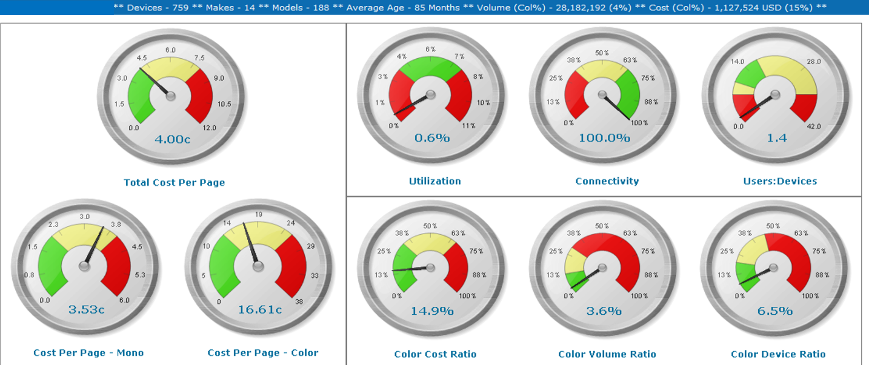
Figure 11 Sample Xerox Assessment Result Gauges

During the Secure and Integrate phase, Xerox focuses on minimizing risk and supporting mobility by:
- Protecting intellectual property from Security threats
- Ensuring regulatory compliance
- Supporting IT infrastructure and integration
- Authorization and authentication for proactive Security management.
Xerox will progress to the Automate and Simplify phase as VITA gains productivity and insights to improve VITA’s business processes with innovative solutions, reduce paper use and provide digital alternatives, increase agility through the cloud and mobile technologies, drive performance and process enhancements with ongoing analytics and analyze how paper is used as an information asset. Xerox conducts workflow assessments to understand VITA’s information workflow and
- Learn how employees use information and documents
- Identify who prints what and where
- Expose opportunities, risks, and anomalies
- Clarify and categorize why documents are printed, shared and moved
- Identify high-value business processes for further analysis and optimization.

A detailed workflow study results in streamlined processes, reduced cost, removes risk and complexity. Examples of relevant automation solutions are below:
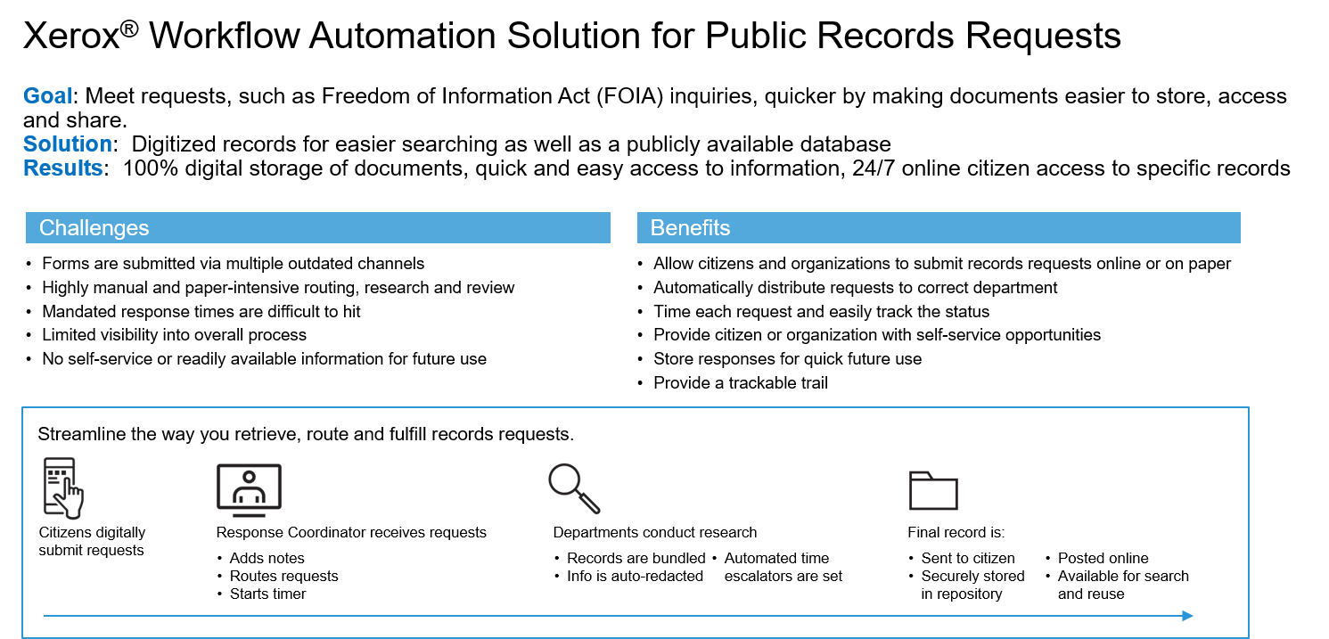
Figure 12. Xerox Workflow Automation Solution for Public Record Requests

Figure 13. Xerox Workflow Automation Solution for Agenda Management
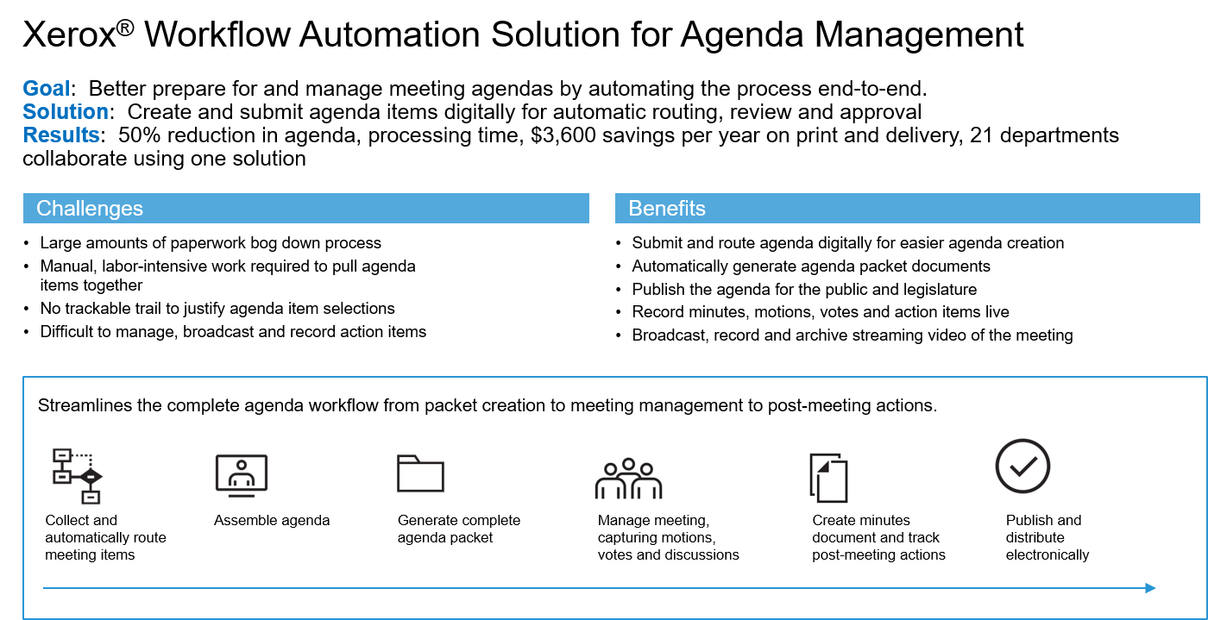

Xerox will provide VITA with visibility and control of document processes and costs, saving money, boosting productivity, and improving document security as well as environmental sustainability. Benefits of a Xerox partnership for MPS include:
- Cutting costs on printing consumables, service, and VITA’s cost-per-page
- Reducing waste by ordering the supplies VITA needs with no “leftovers” as well employing print accounting tools that eliminate the need for banner sheets and unclaimed prints
- Securing data and Visibility into metrics by utilizing authentication/authorization/accounting tools
- Controlling and forecasting budgets accurately by setting VITA’s printing and supply costs up-front
- Freeing up IT resources for more business-critical tasks rather than installing, supporting, and maintaining output Devices
- Ensuring Devices stay up to date through remote maintenance and lifecycle management
- Increasing uptime with automated service/supply dispatch and meter reads a collection
- Reducing energy consumption through Device refresh and consolidation

Table 8. Benefits of a Xerox Partnership for MPS
Without Xerox Managed Print Services | The Xerox Managed Print Services Advantage
Unknown and uncontrolled print cost | Predictable costs
Color toner cost is unpredictable and out of control | Fixed cost-per-page
Separate processes for multiple providers of service and supplies | One Help Desk for service and supply ordering
Excess supplies on hand or not available when VITA needs them | Supplies shipped for next day delivery
Multiple vendors and suppliers for consumables and services | One solution provider
Unknown Print Volume | A monthly report detailing print activity
High Print coverage on documents can be costly | Cost is unaffected by high print coverage

As mentioned above, the Xerox MPS Solution includes a proactive just-in-time supplies replenishment process that applies to all networked print Devices regardless of Device type or manufacturer for all locations. This process ensures that printers and MFPs are provided with supplies in a timely way and with minimal action on the part of End Users or IT. Using the Xerox tool suite, Xerox is able to monitor consumable levels and Xerox proactive monitoring will alert the MSI Help Desk team when supplies get low that an item has been scheduled for delivery to the Customer.
This information will be relayed to Xerox’s Help Desk who orders the consumables for delivery “just-in-time,” so that Agencies are no longer required to order or purchase any consumables, including those for non-Xerox Devices. Xerox designed the just-in-time supplies replenishment program to comprehend the shipping times required to get supplies to VITA’s remote locations. In addition, through the Xerox Services Portal, End Users can request supplies directly; this need should be minimal due to the pre-emptive capabilities of the Xerox MPS Solution.
Xerox’s processes and tools will ensure the majority of Device problems and supply issues, on both Xerox and non-Xerox Devices, are logged before VITA’s End Users become aware of them. In addition, Xerox will provide compatible Consumable Suppliers for non-Xerox Devices. These compatible Consumable Supplies produce excellent quality, high yield and improved price per impression rates, and are guaranteed to perform without causing operational issues in the Device. With Xerox’s tools, Xerox can assist in configuring print queues with defaults that match the published print policy. For example, configure all printers to print duplex and configure color printers to print in black and white, by default.
Expanding on job tracking and control capabilities, print policies can be implemented, as required by VITA or the Customer, to present users with alternate printer recommendations, as an intelligent job routing strategy. Print jobs are processed against established print policies, and Users will be directed to leverage an alternate print Device that conforms to the desired print behavior. Alternate recommendations can be based on a variety of options, such as color versus black and white, job size, chargeback price, time of day, duplex versus simplex, and Device locations.
Strategies for Reducing Print
Xerox’s Managed Print solution will optimize printing operations, both at the Device and User level. To accomplish both, Xerox recommends establishing print governance rules as well as employing new and innovative tools from within the secure & integrate and automate & simplify planks of Xerox’s Managed Print Services solution spectrum that encourage personal print management and reduce print volumes.
Governance
Xerox will establish a print policy and configure print queue default which is recommended for all Agencies engaged in the managed print solution. Taking these actions is the first step in reducing “bad” print – that is pages that never should have been printed or prints that did not leverage cost-saving selections by printing simplex mode and printed in color without cause.
- Print Policy: Establish a formal print policy that communicates VITA’s standards and policy on printing and the use of output Devices. This can include limiting printing of emails; large print jobs are routed to a print center and the reduction or elimination of local printers. Each of these gives Users pause to more carefully consider their desire to print and result in Users choosing to print less. Without enacting any other controls, Xerox has found that simply deploying a Xerox Managed Print Service and a print policy typically reduces overall print by 10%.
- Print Queue Defaults: Configure print queues with defaults that match the published print policy. For example, configure all printers to print duplex and configure color printers to print in black and white, by default.
- Print Controls: Xerox’s authentication, approval, and accounting solution will be implemented during the refresh phase which will track usage by user level, department level, and Agency level reporting. Xerox has found that this solution results in changes in behavior that yield immediate savings from a reduction in printing. Additionally, this technology will identify areas of opportunity to redirect print to more cost-effective printers. For more details on Xerox Print Management and Mobility Suite, please refer to Section 2.3.1 within this document.

Initial Operating Capability
Xerox will plan, analyze, and execute the transfer of all current networked print and imaging services. This includes the buyout of approximately 4,000+ Devices. Xerox assumes the ownership, operation, management, and maintenance of all Devices in accordance with SMM and VITA Rules. This includes performing all existing projects and work orders that are open as of or scheduled beyond the Commencement Date in accordance with VITA’s approved project schedule, the SMM, and VITA Rules.
Xerox will provide service to all existing Devices, Software, and configurations that are currently managed by the incumbent to include those not planned for inclusion in the Xerox Service Catalog. Upon Effective Date, Xerox will do a full inventory and analysis of current products with a plan for each product to test for Security, refreshes, issues, and provide an updated status. As part of Xerox’s ownership, Xerox will maintain the Incumbent print and imaging Devices to include the follows:
- Performing break/fix services – these services will be reactive upon Commencement. Post-transition, the Device's services will be proactive.
- Perform Device replacement for all incumbent Devices and services – upon Xerox’s review of products, Xerox will make a recommendation as to whether incumbent Devices and services should be refreshed or upgraded with Xerox or other third-party products.
Xerox supports both networked and locally connected Xerox and non-Xerox Devices. Support for service and supplies for networked Devices is provided both proactively through Xerox’s Tool Suite and reactively through the MSI Help Desk, while service and supplies support for local Devices is provided reactively. Service for networked printers includes all parts and Consumable Supplies except paper. This includes maintenance kits and other parts. Pricing for local Devices will be based on a flat rate that can be provided for optional consideration at a future date.
As part of Xerox’s continuous improvement process, Xerox will examine existing Executive Branch Agencies-printer contract commitments and make recommendations for potential cost-saving opportunities. Any findings will be reported with information pertaining to potential cost savings along with how the analysis was done.
Xerox will service all Agency locations. The Xerox Help Desk will be available 24x7x365, and service technicians will respond on-site Monday through Friday 7:00 A.M – 7:00 P.M.
Transition
Xerox will ensure VITA’s satisfaction throughout each phase of the Implementation and transition lifecycle by designating a Project Manager (PM) to lead the Implementation and transition plan development. Xerox PMs are highly trained in Project Management Institute (PMI) principles that will be used throughout the project-planning phase. Also, Xerox will utilize their Global Service Delivery Model (GSDM), which is Xerox’s service strategy based on the ITIL framework, to implement, assume and manage all in-scope Devices under the VITA Managed Print Service tower.
One of the key planks of the GSDM is the Transition and Transformation Management Process (TTMP). The TTMP is a proven methodology based on PMI (Project Management Institute) principles that Xerox will utilize when implementing the managed print services solutions. This process will be customized to meet the needs of VITA and the other tower partners. This process is aligned to the following standards and is continuously maintained and updated from experienced Xerox Transition and Project Managers:
- Project Management Institute (PMI)
- Prince 2
- Lean Six Sigma
- ITIL.
The TTMP covers the standard activities involved in planning, startup, and transformation of VITA’s environment from its current state of operations to a Xerox mode of operation. Xerox’s TTMP methodology was developed based upon Lean Six Sigma principles and best practices and standards from numerous global transitions to leverage as the foundation for constructing successful Project Plans. This standardized methodology ensures seamless integration of Xerox Managed Print Services into VITA’s Environment. During this phase, a collaborative approach is used to develop a work breakdown structure (WBS) with the milestones required to achieve a quick and efficiently-implemented solution that meets the agreed upon scheduling requirements. A standardized approach that includes workshops and checkpoints are used to verify the progress against the baseline milestones. Standard collaterals are developed to support the process. These include defining specific roles and responsibilities, detailed procedures manual, a detailed schedule for site implementations, and specific project management tools to control and govern the process.
The Transition and Transformation Management Process (TTMP) will include the following phases:
Initiating - These are the activities required to start the project. These include a transfer of responsibility from the presales or RFP team to the Implementation and transition management team, initiation of the project-planning package, setup of project tracking systems and a client kick-off meeting. The planning and preparation of the Xerox internal team is key to the success of this phase.

Planning - These are the activities required to develop an approved project plan, such as establishing schedules, finalizing work breakdown structures, assigning resources, identifying risks & risk mitigation strategies, and developing communications plans. Collaboration between Xerox and VITA / Agency subject matter experts is key to the success of this phase.

Executing - These activities are required to complete the project plan deliverables, that is, to perform the specific tasks required to satisfy the requirements of the project. Xerox and VITA / Agency adherence to the agreed-upon schedule for all deliverables is key to the success of this phase.

Monitoring & Controlling - These activities are required to track and regulate progress toward the project plan deliverables. These include reporting, reviews, project change control and implementing risk mitigation strategies. Establishing appropriate governance and a management framework including both Xerox and VITA / Agency membership is key to the success of this phase.

Closing - These activities are required to bring the project to completion. These include finalizing process documentation, conducting lessons learned reviews and transferring responsibility to the steady state service delivery team. Operational readiness confirmed by both Xerox and VITA is key to the success of this phase.
Implementation Project Tracking will be created and shared with VITA to ensure that there is visibility throughout the implementation process. To be efficient, the Xerox Transition Executive along with the VITA Project Manager will agree upon the critical few items Xerox needs to measure on a daily, weekly and monthly basis. Xerox’s use of technology and tollgates will ensure compliance with the needs of VITA.
Cultural Change Management
The other half of the equation for creating seamless change is in establishing an effective change management plan. While the services provided at the Commencement Date will not be disruptive to Customers, managing the resistance and discomfort experienced by people in an organization when new processes or technologies are introduced is critical to the success of the change. Xerox will provide a comprehensive and effective change management plan to reduce disruption to day-to-day business and enable Customers to realize the benefits of the new process more rapidly, accelerate adoption rates, and increase organization, end-user confidence, and satisfaction in the new process. Xerox understands the important role that cultural change management plays in the success of VITA’s transition to the Xerox Managed Print Services solution and therefore has invested in this area by providing Cultural Change Management of Xerox North American Professional Services.
Xerox will use a three-phase methodology which has proven successful for large-scale change and is shown below:
- Project Start-up
Phase 1: Program Level Direction:
- Create Vision and Direction.
- Build Excitement for the Transformation.
  - Understanding and developing the environment for change.
  - Stakeholder analysis.
  - Ensure executive sponsorship.
  - Understanding organizational resistant behaviors.
  - Identify the risks.
  - Demonstrate the necessity and importance of a timely change initiative.
  - Gain acceptance for change.
  - Create the vision for deploying and accepting the change.
  - Build excitement for the change.
  - Develop a print policy.
  - Manage expectations.
- Implementing the Changes
Phase 2: Just-In-Time Communications:
- Implementation of Devices.
- Lead users through changes.
  - Facilitating and enabling the entire organization.
  - Address any known barriers.
  - ‘Walk the talk’ - demonstrate the desired behavior.
  - Utilize appropriate training techniques.
  - Communicate short-term successes (pilot, one-site, one building).
  - Continual on-going communication of the program to users
  - Keep pushing for full adoption.
- Steady State
Phase 3: Turning Initiative into Best Practice
- Regular Communications through variety of channels.
- Incorporate Feedback Loops (surveys) to enhance the program.
  - Turning an initiative into a best practice.
  - Survey to measure program success.
  - Communicate the effectiveness and success of the program.
  - Create a new culture.
Xerox will work to understand the challenges that VITA anticipates and then provide Change Management Deliverables that enable VITA, the Agencies and Xerox to share the same understanding of the change end users will face and address these changes through management. Xerox will conduct a workshop with VITA with the following as a draft agenda:
- Introductions
  - Cultural Change Management Program Overview
  - Assessing the organizations change readiness and ability to accept change
  - Identify end-user type
  - What will change during implementation for employees
  - Identify and understand barriers and how do we reduce resistance behaviors
  - Develop a program theme and supporting elements
  - What do we communicate
  - How do we communicate these changes (communication vehicles)
- Deliverables that result from that workshop include the following
  - Overview of the next steps
  - High-Level Plan for Content Development, Branding Review, Approval and Distribution Processes
  - Approval Timeline & Processes
  - Content Development
  - Schedule next conference call(s) for review of content development, discuss approval and distribution process (in alignment with the transition schedule)
- Some examples of deliverables throughout the process include

  - Executive message
  - Communication Plan
  - FAQs
  - Training session notification
  - Print guidelines
  - Coming Soon poster
  - Intranet ideas
  - Key Device Contact Roles
  - Flyers: I’m Being Replaced, 1st Day Getting Started,
  - Product photography

Enhanced Services

Value Added Services
Xerox will offer a multitude of solutions that extend the value of VITA’s Xerox ConnectKey® multifunction devices and leverage a Xerox-driven MPS environment that enhances productivity, security, convenience, sustainability results and ultimately allow agencies to serve their constituents faster.
Xerox App Gallery
As part of Xerox’s Value-Added Services, Xerox is able to provide additional services and offerings through Xerox’s App Gallery. These native apps simplify print, scan, and copy functions and provide access to contact lists and frequently used locations. At the same time, apps available through the App Gallery allow users to download server-less apps, like REDACTED and REDACTED, directly from the user interface.
With Xerox App Studio and Personalized Application Builder (PAB), Xerox offers a more sophisticated level of customization to automate unique workflow requirements that streamline processes and helps end users become more productive.
The new Xerox Easy Translation Service app, available on new and upgraded ConnectKey® devices is a first-of-its-kind solution that leverages cloud technology and is designed for one purpose: to empower people to easily and securely translate documents, at any time, and from any device. The app allows users to scan a hardcopy document through their MFP or snap a photo from their phone, then securely and quickly translate the contained on the digital file to more than 40 languages and in over 20 different formats.
Imagine an MFP that can translate a document into more than 40 languages, or be customized and built to meet VITA’s business needs. The Xerox MFPs of today is built on Xerox’s innovative ConnectKey® platform that combines technology and software apps to automate key work processes.
- Simply scan the document using the app on VITA’s Xerox ConnectKey® enabled multifunction printer or snap a photo with VITA end users’ smartphone.
- Select VITA’s preferred language(s).
- Immediately receive a translation via e-mail and/or printed via MFP, maintaining the formatting of the original document.
The Easy Translation Service app is available on all Xerox ConnectKey® iSeries MFPs and does not require the additional upfront purchase of hardware or software. Maintenance and support are also included after the application has been deployed to each applicable device.
Xerox Extensible Interface Platform
The Xerox Extensible Interface Platform (an open architecture software platform available on all ConnectKey® Technology enabled devices from entry-level printers to large office multifunction printers) allows Xerox to offer sophisticated solutions for document management, workflow automation, security, and accounting.
With the Extensible Interface Platform, VITA’s ConnectKey® -enabled printer or multifunction printer can adapt to the way VITA works with comprehensive, custom productivity-enhancing solutions for document management, accounting, mobile printing, and user access controls.
Xerox Print Awareness Tool
As a future consideration, another potential step in reducing print is to help Users understand the print they are producing and encourage them to change their printing behavior. The Xerox Print Awareness Tool (XPAT) presents a unique approach to reducing print volumes and sustainability management. XPAT is an interactive desktop widget that uses specific insights to help Users better understand the pace with which they consume paper. XPAT leverages multiple change management techniques to empower and motivate VITA’s employees to print less. By encouraging responsible print decisions (such as utilizing secure print functionality or duplex print options to reduce consumption levels) and by providing individualized feedback regarding personal print behaviors, XPAT shows employees how they can make a real impact on overall print reduction and sustainability strategies.
XPAT features a graphic end-user dashboard display that is customized to each individual with unique user profiles that allow users to see their print usage with an easy, interactive desktop interface and lays out steps they can take to improve their print behavior. This solution allows organizations the ability to implement reward and incentive programs for responsible print behavior and measure performance against organizational reduction goals.
The Xerox Print Awareness Tool (XPAT) is a snap-in tool that encourages personal print management and reduction of print volumes by providing a change management technique to educate individuals on their individual impact on print.
The benefits of the Xerox Print Awareness Tool include:
- Raises user awareness
- Promotes social conformity
- Provides incentives for responsible printing habits
- Real-time print metrics for users
- Adds an element of fun and teamwork to an important change of workplace habits
The Xerox Print Awareness Tool encourages co-opetition (cooperative agreement on standards and sharing of information among competitors) in an effort to change individual user printing habits without a forced management directive.
The result of the Xerox Print Awareness program is volume reduction. Clients experience a reduction of 10-20% in total print volumes as a result of the implementation of the Xerox Print Awareness Tool. In addition to the expected cost savings, the reduction in print volume can be tracked over time and reported as part of VITA’s sustainability initiatives.
Workflow Automation
Removing the paper from VITA’s processes is the most-effective way to reduce print since it does not rely on User behavior. As paper-intensive processes are streamlined through automation, and the removal of non-value added steps, agencies will not only benefit from the print reduction, but also through the elimination on human-based errors and significantly reduced process cycle times that better serve their constituents.
Xerox Workflow Automation provides a way for businesses to use a simpler framework and remove the paper bottleneck in typical internal and client-facing processes. Xerox Workflow Automation enables a way to capture information at the MFD and transfer this information directly into Customers’ existing content management platform(s). In addition, services for the bulk capture of paper backfiles ensure that critical processes are simple, secure, and automated. This can also reduce cost and time to retrieve critical data while increasing compliance across the board. For example:
- Front Office Solutions
  - Client On-Boarding – Reduce cycle time for the client account opening.
  - Recruitment – Personalized communication and marketing collaterals.
  - Statement Creation – Personalized and multi-media.
  - Customer Service – Aggregation of paper communication, social media communication, and telephony data to support customer care processes.
- Back Office Solutions
  - Expense Processing – Electronic expense claims with the scanning of receipts.
  - Invoice Processing – Automated capture and matching of invoice data into finance system.
  - Project Communications – Workgroup sharing and workflow creation for unstructured project teams.
Leveraging the ConnectKey® MFDs as portals, Xerox Workflow Automation Solutions address customer needs, acting as a bridge between Xerox’s products and important business and process workflows of VITA Customers.
Xerox Workflow Automation Solutions for the Public Sector can help government agencies manage documents and records in an entirely new way by migrating their manual, paper-intensive business processes to automated digital processes, delivering a transformational experience for VITA’s constituents. From automated routing and digital repositories to integrating tablets and capturing analytics, Xerox’s government workflow solutions make document processes fast and efficient. Xerox offers a suite of software and services in support of these solutions including:
- Business Process Assessment Services to document the current state, develop a future state vision and recommended process and provide an ROI for a proposed solution
- Document Scanning Services to digitize and index paper documents for migration to electronic storage and/or an Enterprise Content Management (ECM) or Document Management solution. These services can be performed off-site or on-site based on customer preferences
- Document Scanning Software to provide MFDs and document scanners with the necessary capabilities to scan, index, quality review and correct scanned images of paper
- Enterprise Content Management software to store and manage native electronic documents as well as digitized paper documents
- Workflow Automation software to manage business processes electronically rather than through manual routing and approval that typically occurs in a paper-based process
- Case Management software to manage “case-based” business processes
- Records Management software to assist the customer in managing records requirements for records lifecycle management
- Professional Services to implement a complete solution that configures the out-of-the-box software to specific requirements of a customer business process or department
All of Xerox’s Workflow Automation Solutions are designed for government specific processes such as electronic plan reviews or property assessments. Below are examples of state government processes and their automated solutions.
Table 9. Workflow Automation Solutions
State Government Process | Desired State | Xerox Automated Workflow Solution | Benefit To Agency | Results Achieved
Agenda Management | Better prepare for and manage meeting agendas by automating the process end to end. | Create and submit agenda items digitally for automatic routing,  review, and approval. | Automate paper-based processes, from preparing for and orchestrating meetings to managing follow-up actions. | Reduction in agenda  processing time  Savings on print & delivery  Multiple departments collaborate using one solution
Electronic Plan Review | Speed up review process so developers can spend more time building in VITA’s community. | Digitize plan documents and enable simultaneous review and mobile collaboration over plans. | Workflow Automation makes reviewing and approving building plans paperless, traceable, and more efficient. | Real-time collaboration and  comment tracking  24/7 access to plans  100% of stored plans  accessible digitally
Affordable Housing | Lighten caseload burden by digitizing document management. | Integrate social housing solution with home-grown software to reduce paper and speed retrieval. | A digital repository for applications and certifications can speed up the process of getting citizens into homes. | Cost savings  Floor space freed up  Faster document retrieval
Property Assessment Appeals | Streamline the appeals process to free up employees and boost responsiveness. | Digital routing and folders  to make the review process  trackable and automated. | Improve responsiveness with a simpler, faster property assessment appeals process. | 11-day reduction in processing time  60% increase in productivity  $0 spent on overtime costs (previously $31,000)
Public Records Requests | Meet public records requests quicker by making documents easier to store, access and share. | Digitized records for easier searching as well as a publicly available database. | Digitize documents to help automate open records management and improve transparency. | 100% digital storage of documents  Quick and easy access to information  24/7 online citizen access to specific records
Judicial Records | Efficiently and securely manage all facility documents and processes. | Store, access and route documents within a central location. | Efficiently and securely manage all facility documents and processes. | $0 in paper transfer fees  $0 in added storage fees  millions saved annually
Xerox has designed additional workflow solutions to target departmental processes. Two examples include Accounts Payable and Human Resources File Management which are described below.
- Accounts Payable - Automate Agency’s finance and accounting processes and provide timely and secure information access to staff and employees, support VITA’s compliance needs and interact with documents and data directly from Agency’s core financial and ERP systems.
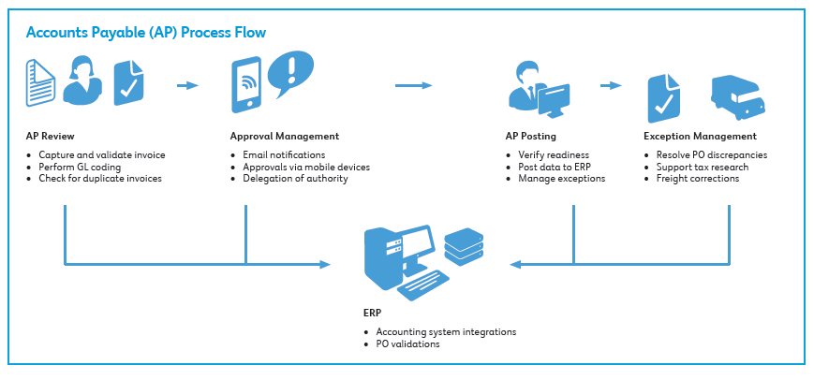
Figure 14. Workflow Automation - Accounts Payable Process Flow
- Human Resources File Management - Automate VITA’s HR processes to provide timely and secure information access to HR staff and employees, conform to VITA’s compliance needs and interact with documents and data directly from VITA’s human resource information system(HRIS).
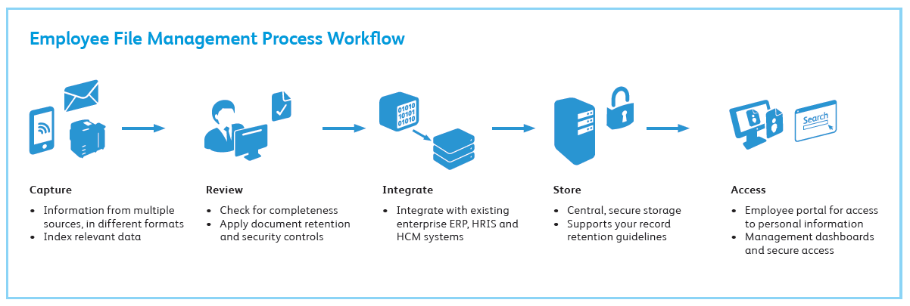
Figure 15. Workflow Automation - Employee File Management Process Flow

