EXHIBIT G

CERTIFICATION REGARDING LOBBYING

The undersigned certifies, to the best of his or her knowledge and belief, that:

- No Federal appropriated funds have been paid, by or on behalf of the undersigned, to any person for influencing or attempting to influence an officer or employee or an agency, a Member of Congress, an officer or employee of Congress, or an employee of a Member of Congress in connection with the awarding of any Federal Contract, the making of any Federal grant, the making of any Federal loan, the entering into of any cooperative agreement, and the extension, continuation, renewal, amendment, or modification of any Federal Contract, grant, loan, or cooperative agreement.
- If any funds other than Federal appropriated funds have been paid or will be paid to any person for influencing or attempting to influence an officer or employee of any agency, a Member of Congress, an officer or employee of Congress, or an employee of a Member of Congress in connection with this Federal Contract, grant, loan, or cooperative agreement, the undersigned shall complete and submit standard Form-LLL, "Disclosure Form to Report Lobbying," in accordance with its instructions.
- The undersigned shall require that the language of this certification be included in the award documents for all sub awards at all tiers (including subcontracts, sub grants, and Contracts under grants, loans and cooperative agreements) and that all sub recipients shall certify and disclose accordingly.

This certification is a material representation of fact upon which reliance was placed when this transaction was made or entered into. Submission of this certification is a prerequisite for making or entering into this transaction imposed by 31 U.S.C. § 1352. Any person who fails to file the required certification shall be subject to a civil penalty of not less than $10,000 and not more than $100,000 for each such failure.

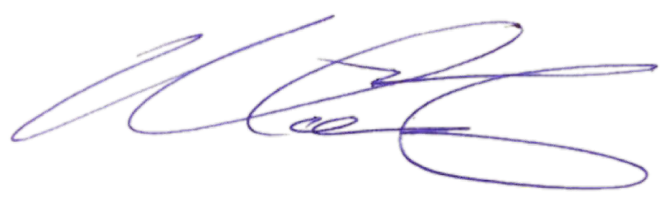
Signature:

Printed Name: Michelle Chaney

Organization: Dell Marketing L.P.

Date: 4/12/2024

